ATome of Battle

Introduction

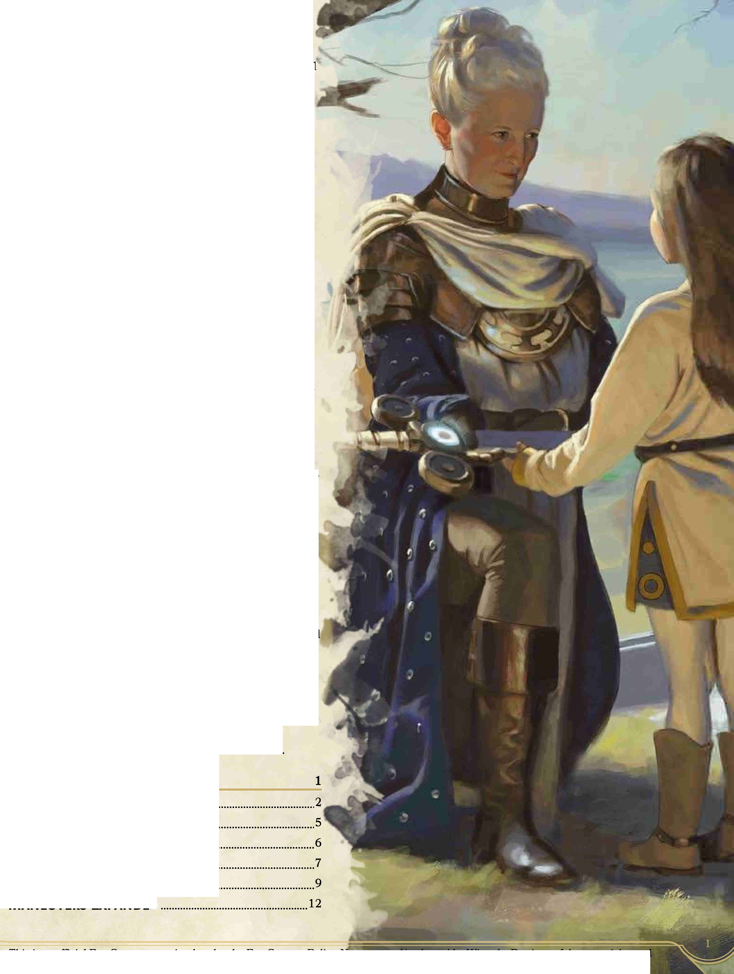

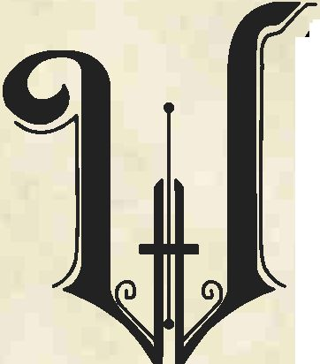

eapon combat in D&D 5E can be somewhat lacking in variety, and often devolves into repeated ”1 hit it with my sword" (always a sword, unless you’re a dwarf!). The revisions in this document attempt to provide martial combatants with meaningful choices on a round-by-round basis, as well as incentives to branch out beyond the rapier, hand crossbow, or greatsword. This is primarily a "gamist" document, so while flavor elements are considered, it does not claim to fix combat to some imagined realistic or historical standard, or expand the weapon list for its own sake. Each set of rules is presented ala carte, so a DM may wish to make available only some of these pages or powers.

In 5E (and previous editions!), interesting combat actions are often locked behind feats, which come around just every four levels, and compete with critical ability score improvements. This document moots certain weak feats (Charger, Grappler) with situationally-effective actions, codifies DMG object damage guidelines for in-combat, and adds ways to do non-magical healing and status effect actions, expending hit dice instead of spell slots. These combat options are intended to be viable for all PCs to use.

For the martial specialist, the rapier, polearm, and greatsword see more use than many of the other weapons in the game, as the major difference between weapons is the associated fighting style. The weapons revision presented here attempt to make a wider range of weapons compelling to warriors, in addition to weapon-specific techniques reflecting specialized training in each weapon's unique advantages, without increasing the ceiling of martial damage.

Stances, an innovation in the 3E Tome of Battle, were an attempt to provide martial characters with situational bonuses during combat. This document modifies 5E's Fighting Style feature, replacing static styles with dynamic stances inspired by Unearthed Arcana and the original Tome of Battle, advanced stances to modify the basic ones, and rules for changing stances mid-combat.

There might be concerns that additional martial maneuvers step on the Battlemaster's toes, but the Battlemaster adds effects and damage to his weapon attacks, while these techniques and special actions are generally used to as a substitute for an attack or action. For example, any character can Disarm, but only the Battlemaster can Disarming Attack. The final section expands Battlemaster maneuvers to include specializations - Cut-Throat, Mystic Knight, Savage, or Warlord - that each represent a different approach to battlefield superiority, plus a standard maneuver group that all battlemasters have access to. The PHB Battlemaster corresponds most closely to the Warlord.

Summary and Weapon Tables Additional Combat Actions... Hit Dice Actions

Combat Stances

Weapon Techniques.. Maneuvers Expanded

c —

Summary and Tables

New and Revised Features

|  |  |  |
| --- | --- | --- |
| **Standard Feature** | **Martial Prowess Feature** | **Page** |
| Weapons Table | Revised Weapons Table | 3 |
| Martial Weapons Proficiency | Martial Weapons Proficiency, +1 Weapon Technique | 9 |
| Fighting Style | Combat Stance (+2 Stances) | 7,9 |
| Extra Attack (2, 3) | Extra Attack (2, 3), +1 Combat Stance (if applicable) | 7,9 |
| Ability Score Improvement | Ability Score Improvement, +1 Weapon Technique (if applicable) | 9 |
| Additional Fighting Style | Hybrid Stance | 9 |
| Combat Superiority | Combat Superiority Revised | 12 |
| Martial Adept Feat | Superior Technique | 12 |

Extra Attack grants a Combat Stance only if the PC has the Combat Stance feature. Ability Score Improvement grants a Weapon Technique only if the PC is proficient with all martial weapons or has the Pact of the Blade or Path of the Kensei feature.

Weapon Techniques

**Any Versatile** Flexible Flurry

Weapons with modified properties are denoted with an asterisk (*} New weapons are *italicized.*



|  |  |  |  |
| --- | --- | --- | --- |
| **Weapon** | **Techniques** | **Weapon** | **Techniques** |
| **Any (Shield)** | Shield Bash | **Longbow** | Pinning Shot, Ricochet, Whistling Shot |
| **Battleaxe\*** | Crippling Cut | **Longsword\*** | Abwenden, Cleave, Crippling Cut, Piercing Strike |
| **Blowgun** | — | **Mace\*** | Crushing Blow, Grazing Clout |
| ***Cestus*** | Close Quarters, Finisher, Grazing Clout | **Maul\*** | Crushing Blow |
| **Dart\*** | Pinning Shot | **Morning-star\*** Piercing Strike | |
| **Club\*** | Finisher, Grazing Clout. Shattering Clobber | **Net** | Entangle |
| **Dagger\*** | Close Quarters, Finisher, Paired Weapon, Pinning Shot | **Pike\*** | Bracing, Lunge |
| **Flail\*** | Crushing Blow | **Quarterstaff** | Lunge, Shattering Clobber, Whirling Rebuff |
| **Halberd\*** | Bracing, Cleave, Lunge, Whirling Rebuff | **Rapier** | Abwenden, Lunge |
| **Glaive\*** | Bleeder, Cleave | ***Saber*** | Abwenden, Bleeder, Crippling Cut |
| **Greataxe\*** | Cleave, Crippling Cut, Whirling Rebuff | **Scimitar\*** | Abwenden, Crippling Cut |
| ***Greatbow*** | Pinning Shot, Ricochet, Whistling Shot | **Shortsword** | Abwenden, Close Quarters |
| **Greatclub\*** | Grazing Clout. Shattering Clobber | **Shortbow** | Bleeder, Pinning Shot, Ricochet, Whistling Shot |
| **Greatsword\*** | Cleave | **Sling** | Grazing Clout, Whistling Shot |
| **Handaxe\*** | Bleeder, Close Quarters, Ricochet | **Spear** | Bracing, Lunge, Whirling Rebuff |
| **Hnd. Crossbow** Whistling Shot | | **Sickle** | Bleeder, Finisher, Paired Weapon |
| **Hvy. Crossbow** Pinning Shot, Ricochet, Whistling Shot | | ***Swordbreaker*** Paired Weapon | |
| **Javelin** | Pinning Shot, Ricochet | **Trident\*** | Bracing, Lunge, Whirling Rebuff |
| **Lance** | Bracing, Lunge | **Warhammer\*** Crushing Blow | |
| **L Crossbow** | Pinning Shot, Ricochet, Whistling Shot | **War Pick\*** | Piercing Strike |
| **L Hammer\*** | Crushing Blow, Grazing Clout | ***War Whip*** | Bleeder, Bracing, Entangle |
| **Improvised** | Close Quarters, Shattering Clobber | **Whip\*** | Bleeder, Entangle |

Revised Weapons

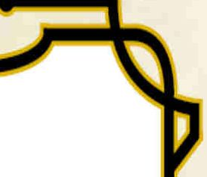

|  |  |  |  |  |
| --- | --- | --- | --- | --- |
| **Name** | **Cost** | **Damage** | **Weight** | **Properties** |
| **Simple Melee** | | | | |
| Club | 1 sp | ld4 bludgeoning | 2 lb. | *Backswing,* finesse, light |
| Dagger | 2 gP | ld4 piercing | 1 lb. | *Bandoleer,* finesse, light, thrown (20/60, *covert)* |
| Greatclub | 2sp | ldlO bludgeoning | 10 lb. | *Heavy,* two-handed |
| Handaxe | 5 gP | 1 d6 slashing | 2 lb. | *Bandoleer,* light, thrown (20/60) |
| Javelin | 5 sp | 1 d6 piercing | 2 lb. | Thrown (30/120) |
| Light Hammer | 2 gP | ld4 bludgeoning | 2 lb. | Light, thrown (20/60), *siege* |
| Mace | 5 gP | 1 d6 bludgeoning | 41b. | *Siege* |
| Pike | 3gP | 2d4 piercing | 18 lb | Heavy, reach, two-handed |
| Quarterstaff | 2 sp | 1 d6 bludgeoning | 41b. | Versatile (1 d8) |
| Sickle | 1 gp | ld4 slashing | 1 lb. | *Finesse,* light |
| Spear (Short Spear) | 1 gp | 1 d6 piercing | 3 lb. | Thrown (20/60), versatile (1 d8) |
| Whip | 2 gP | ld4 slashing | 3 lb. | *Entrapping,* finesse, reach |
| **Simple Ranged** | | | | |
| Blowgun | lOgp | ld4 piercing | 1 lb. | Ammunition, loading, ranged (2 5/100, *covert)* |
| Light Crossbow | 25 gp | 1 d8 piercing | 5 lb. | Ammunition, loading, ranged (80/320) two-handed |
| Dart | 5 cp | ld4 piercing | 1/4 lb. | Light, thrown (20/60, *covert), bandoleer* |
| Shortbow | 25 gp | 1 d6 piercing | 2 lb. | Ammunition, ranged (80/320), two-handed |
| Sling | 1 sp | ld4 bludgeoning | — | Ammunition, ranged (30/120) |
| **Martial Melee** | | | | |
| Battleaxe | lOgp | *2d4* slashing | 41b. | — |
| *Cestus* | 5 sp | *ld4 bludgeoning* | 1/2 lb. | *Light, special* |
| Flail | lOgp | *2d4* bludgeoning | 5 lb. | *—* |
| Halberd (Polearm) | 20 gp | ldlO slashing | 6 lb. | *Bladed,* heavy, reach, two-handed |
| Glaive | 20 gp | *2d4* slashing | *5 lb.* | Heavy, reach, two-handed |
| Greataxe | 30 gp | ldl2 slashing | 7 lb. | *Backswing,* heavy, two-handed |
| Greatsword | 50 gp | 2d6 slashing | 6 lb. | *Bladed,* heavy, two-handed |
| Lance | lOgp | ldl2 piercing | *7 lb.* | *Heavy,* reach, special |
| Longs wo rd | 15 gp | 1 d8 slashing | 3 lb. | *Bladed,* versatile (ldlO) |
| Maul | lOgp | 2d6 bludgeoning | 10 lb. | Heavy, two-handed, *siege* |
| Morning-star | 15 gp | *2d4* piercing | 5 lb. | *—* |
| Rapier | 25 gp | 1 d8 piercing | 3 lb. | Finesse |
| *Saber* | 12gp | 1 d6 slashing | 2 lb. | Finesse, light |
| Scimitar* | *25 gp* | *ld8 slashing* | 3 lb. | Finesse |
| Shortsword | lOgp | 1 d6 piercing | 2 lb. | Finesse, light |
| *Swordbreaker* | *25 gp* | *ld4 piercing* | *1 lb.* | *Entrapping, finesse, light* |
| Trident (Long Spear) | 5 gP | 1 d8 piercing | 41b. | Thrown, versatile (ldlO) |
| Warhammer | 15 gp | 1 d8 bludgeoning | *41b.* | *Backswing, siege,* versatile (ldlO) |
| War Pick | 5 gP | 1 d8 piercing | *6 lb.* | *Heavy, siege* |
| War Whip | 5 gP | 1 d6 slashing | 41b. | *Entrapping,* reach |



Revised Weapons (Cont.)

**Weight Properties**

**Name**

**Cost Damage**

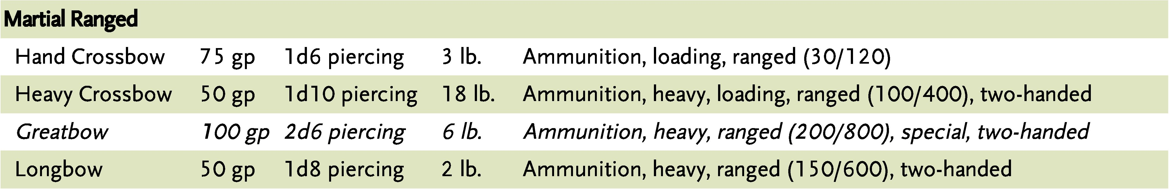

1 gP

3 lb. *Entrapping,* special, thrown (range 5/1 5)

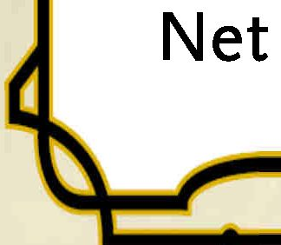

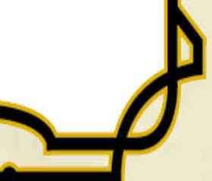

New and Revised Weapon Properties

Backswinc

When you make a weapon attack with this weapon and miss, your next attack roll on this turn has advantage.

Bandoleer

When making a thrown weapon attack, you draw the weapon from an appropriate container or case as part of the attack.

Bladed

The damage type of this weapon is piercing or slashing (your choice}

Covert

If you are hidden, a missed ranged attack does not reveal your location.

Entrapping

When you want to catch and restrain a weapon in combat, you can use the Attack action to make a special melee attack, an entrapment attempt with this weapon. If you have multiple attacks as part of the Attack action, this maneuver replaces one of them. The target of your entrapment must be within the reach of your weapon and wielding a melee or ranged weapon.

Make a Dexterity (Sleight of Hand) check contested by the target’s Strength (Athletics) or Dexterity (Acrobatics) (its choice} A creature wielding a weapon in two hands has advantage on this check, and a creature larger than you automatically wins. If you win, the target can’t make attacks with the entrapped weapon until the entrapment ends.

You can’t move out of your weapon’s range, make an attack with the entrapping weapon, or drop your own weapon without releasing the entrapped weapon, which you can do at any time. If at any time the target is no longer within your weapon’s reach, the entrapment ends.

Heavy

A heavy weapon’s size or mass make it difficult to use without counterbalancing weight; Small and Tiny creatures have disadvantage on attack rolls with a heavy weapon. Small and Tiny creatures may craft versions of these weapons that are more suited to them, with the size of all damage dice reduced by 2 (e.g. ldlO becomes ld8, 2d6 becomes 2d4, etc.}

a k

Escaping an Entrapment

A creature can use its action to attempt to free its entrapped weapon by making a Strength (Athletics) or Dexterity (Acrobatics) check contested by your Dexterity (Sleight of Hand).

F

Siege

This weapon deals double damage to structures and objects.

New Weapons

Cestus

The cestus, or brass knuckles, are any striking glove or weapon that protects the hand while adding power to strikes. Claw weapons may deal slashing or piercing damage instead.

**Special,** Your attacks with this weapon are also considered to be unarmed strikes.

Greatbow

A greatbow is a massive arc of sturdy wood, much larger than a typical longbow, with draw weight beyond the strength of most men. It cannot be used while mounted, and readying or stowing it uses your bonus action or action, instead of an object interaction. Creatures with less than 15 Strength make attacks with the greatbow with disadvantage, while creatures with less than 11 strength cannot draw it at all

**Special:** You add your Strength modifier, instead of of your Dexterity modifier, to your greatbow damage rolls.

Saber

A curved, single-edged sword often used by light cavalry.

Swordbreaker

A dagger with a series of hooked, horizontal notches opposite the blade, used to catch and entrap the opponent’s weapon.

War Whip

A whip reinforced with metal, juijieban, kusarigama, meteor hammer, or any martial variant of the whip.

Additional Combat Actions

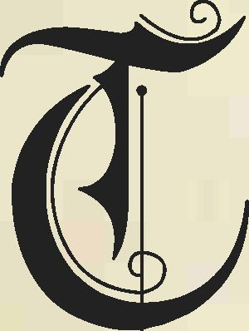

hese additional combat actions are intended to provide access to movement, conditions, and effects that are not possible in the base game. Some of these actions are intended to replace lower-tier combat feats, such as Charger and Grappler, which should be removed from play.

Castle

As an action, you can move into the space of a willing creature within 5 feet of you, moving the creature into the space you previously occupied You must both fit in the space available. Neither you nor the target provoke opportunity attacks for this movement.

Charge

You can use your momentum to enhance your rushing attack. When you, or your mount, uses an action to Dash and you move at least 10 feet in a straight line towards a creature, you can make one melee attack against it as a bonus action. If you hit, you can choose to push the creature 5 feet away from you. Hit or miss, your speed becomes 0 until the end of your turn.

Disarm

*DMGpg. 271, revised*

You can use a weapon attack to knock a weapon or another item from a target’s grasp by making an attack roll contested by the target’s Strength (Athletics) check or Dexterity (Acrobatics) check (its choice). If you win, the attack causes no damage or other ill effect, but the defender drops the item. Items that are worn or attached cannot be disarmed

You have disadvantage on your attack roll if the target is holding the item with two or more hands. The target has advantage on its ability check if it is larger than you, or disadvantage if it is smaller.

Distraction

When you take the Attack action, you can replace one of your weapon attacks with a move that puts an enemy off-balance. Make a Dexterity (Sleight of Hand) or Charisma (Deception) check against the Wisdom (Perception) check of a creature within 5 feet of you. If you win this check, the creature cannot take reactions until the end of its next turn.

Overrun / Tumble

*DMG pg. 272, revised*

When you try to move through a hostile creature’s space, you can try to force through by overrunning the creature. As an action or bonus action, make a Strength (Athletics) check contested by the creature’s Strength (Athletics) check. You have advantage on your roll if you are larger than the creature, or disadvantage if you are smaller. If you win, you can move through (but not end your turn in) the hostile creature’s space once on this turn.

Alternatively, you can attempt to duck, dodge, and weave past the hostile creature. As an action or bonus action, make a Dexterity (Acrobatics) check contested by the creature’s Dexterity (Acrobatics) check. If you win, you can move through (but not end your turn in) the hostile creature’s space once this turn. If the creature wins, it can use its reaction to attempt to shove you prone.

Seize

While grappling a target that is your size or smaller, you can attempt to pin it with an additional free hand As a special melee attack, make another grapple check. If you win, both you and the target are restrained until the grapple ends, and you can choose one of the following additional effects:

* You maneuver to the target’s side or back. While restrained, the creature cannot attack you.
* You pin the target's hands and arms. While restrained, the creature cannot cast a spell with a somatic component, draw a non-light weapon, or take the Use an Object action.
* You cover the target’s mouth and muffle its speech. While restrained, the creature cannot be heard clearly beyond 15 feet, or at all beyond 30 feet. If the creature attempts to cast a spell with a verbal component, it must make a Dexterity saving throw against a DC of 8 + your Strength modifier. On a failed saving throw, the spell fails but the spell slot is not lost.

A creature can be subject to only one of these effects from each creature grappling it.

Sunder

*DMG pg. 246, extended* When you use your action to attack a creature with a melee weapon, you can attempt to break a weapon, shield armor, or object the target is wearing or holding. The attack roll is made against the object’s AC, plus the Dexterity modifier and any circumstantial or magical bonuses to AC of the creature holding or wearing it. The object has three-quarters cover if it is not being held and you have disadvantage on the attack roll if the object is more than one size smaller than the target.

On a hit, you deal damage to the object. If the object is reduced to 0 hit points, it is broken and can't be used in a normal fashion until it is repaired The AC of sundered armor is reduced by 2 instead An item can be repaired via magic or by spending 1 hour using an appropriate set of tools, possibly requiring part of the item’s value in raw materials.

The hit points and AC of an object are subject to your DM's discretion, with some guidelines provided here and in the DMG. Most creatures wield weapons and shields that are small, resilient objects with 11 (3d6) hit points, while most medium-sized armor has 5 (ld8) hit points for each point of AC above 10. Most leather or wood objects have 15 AC and iron or steel objects have 19 AC. Most adventuring equipment has resistance to nonmagical damage and immunity to psychic and poison damage. Magical weapons or objects may be immune to sundering damage.

Tackle

You charge an opponent, attempting to subdue it using your momentum and weight. When you use your action to Dash and you move at least 10 feet in a straight line towards a creature, you can attempt to grapple or shove it as a bonus action. If you win the grapple check, the target is knocked prone and either grappled or pushed 5 feet (your choice). Otherwise, the target is unaffected In either case, you are knocked prone and your speed becomes 0 until the end of your turn.

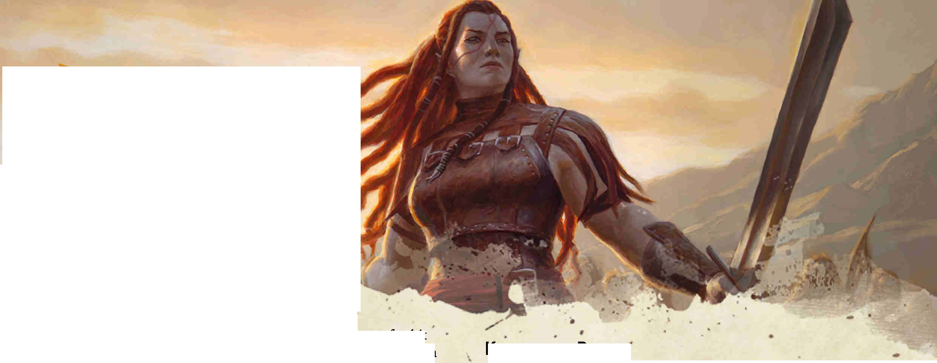

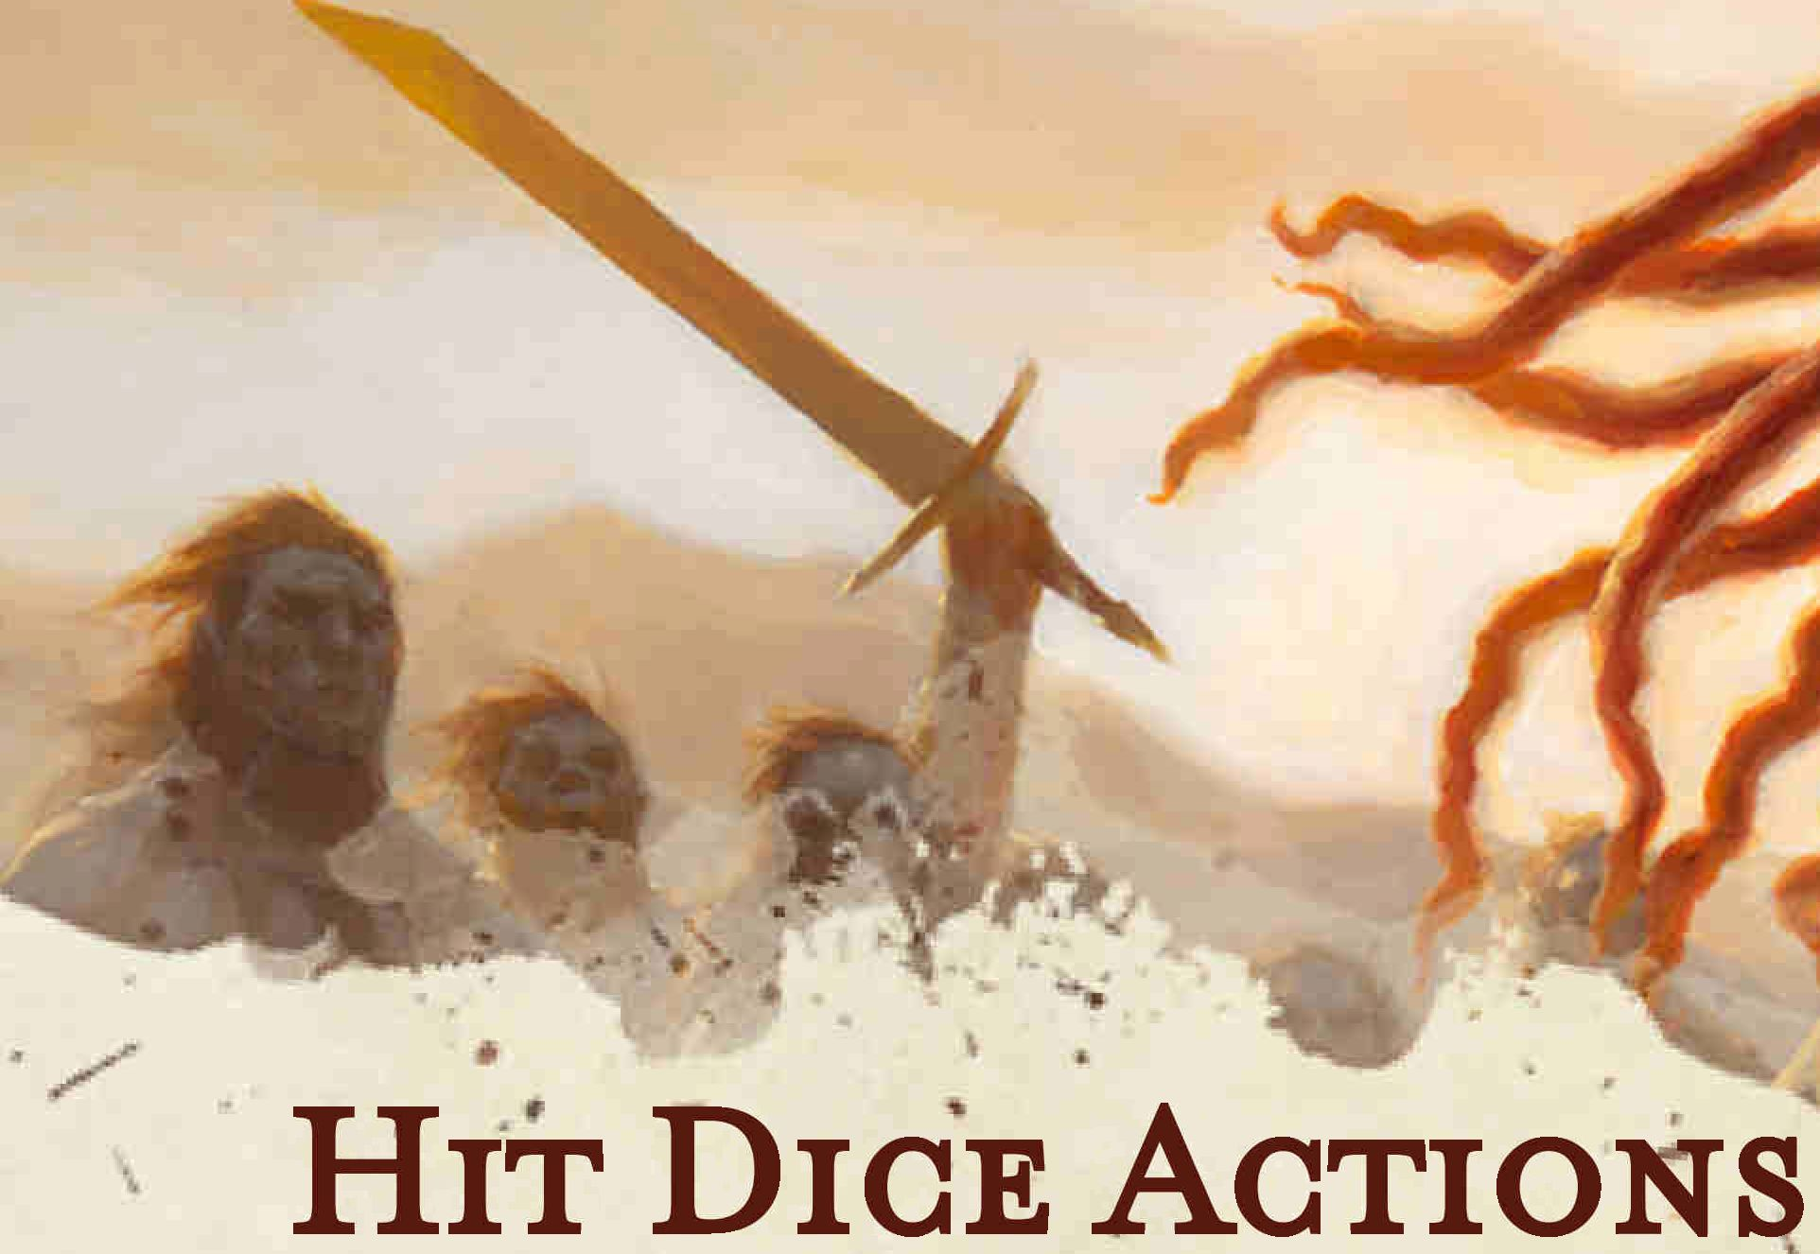

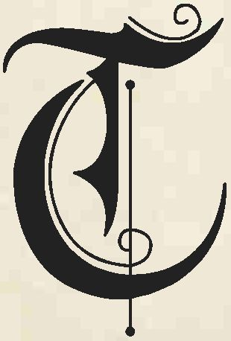

he following actions are experimental uses for hit dice, which are used only for short-rest healing in a standard 5th Edition game. These maneuvers are more impactful than the combat actions provided in the previous page, so they are listed separately.

The intent of these actions is to provide mundane characters access to effects and conditions that are only available to magical ones in the base game, such as the frightened or unconscious conditions. For instance, in­combat nonmagical healing is extremely limited (e.g. the Healer feat), and the First Aid skill presented here is not intended to replace but to supplement it with resource­draining healing.

Coup de Grace

As an action, you attempt to finish a helpless opponent, one that is unconscious, paralyzed, or otherwise rendered unable to take actions or movement (the incapacitated condition is necessary but not sufficient). Expend a hit die and deal an automatic critical hit with a melee weapon or spell attack. If the creature survives the damage, it must succeed on a Constitution saving throw against a DC equal to 10 or half your damage roll, whichever is higher. On a failure, it dies. A rogue applies sneak attack damage when delivering a coup de grace.

Delivering a coup de grace provokes opportunity attacks from creatures within 5 feet of you and reduces your speed to 0 until the end of the turn.

First Aid

As an action, you bind wounds and apply simple first aid with a Healer’s Kit. Expend a use of the kit and make a DC 10 Wisdom (Medicine) check targeting a creature within five feet of you that has less than its maximum number of hit points. On a success, the target can expend one hit die, plus one additional die for each 5 points you exceed the DC. Roll the expended dice, and the target regains hit points equal to the result (do not add the target’s Constitution modifier).

Heroic Resolve

When you make a death saving throw, you can choose to expend a hit die and add the result to your die rolL You must choose to do so before making the rolL If you roll a 1 on the d20 but the total result would succeed, you gain one failure instead of two.

Each time that you use a hit die in this way, you recover one fewer hit die (minimum zero) during your next long rest.

Knockout Blow

The first time you hit a surprised creature with a bludgeoning attack, you can try to knock it out. Expend a hit die and roll damage as normal Instead of taking damage, the creature must succeed on a Constitution saving throw against a DC equal to 10 or half your damage roll whichever is higher, or it is rendered unconscious for 1 minute. The target awakens if it takes damage or another creature uses an action to wake it. This ability has no effect on constructs and undead.

Hurl

If you are grappling a target your size or smaller, you can exert yourself in an attempt to hit it with the ground As a special melee attack, expend one or more hit dice, up to a number equal to your Strength modifier. You sling the creature 5 feet away from you and it must make a Dexterity saving throw against a DC equal to 8 + your Strength (Athletics) modifier, or it is thrown an additional 5 feet per hit die expended and lands prone. The creature takes bludgeoning damage equal to your Strength modifier, plus ld4 for each 5 feet it was thrown.

Sprint

Pushing yourself to go slightly faster, you overexert yourself while moving into or out of danger. As a bonus action, you can expend a hit die and move just a bit farther in a turn, gaining an amount of walking speed equal to 5 x half the die roll (rounded up) until the end of your turn. You cannot use this ability if your speed has been reduced by an effect or condition.

At the end of your turn, make a Constitution saving throw against a DC equal to 20 minus your remaining number of hit dice. On a failure, you gain one level of exhaustion.

Terrorize

Through a display of strength, martial prowess, or sheer attitude, you attempt to spook one or more creatures with less than half maximum hit points or fewer than 12 maximum hit points. Every target must be within 15 feet of you. As an action, expend one hit die per target; each creature must make a Wisdom saving throw against a DC of 8 + your Strength (Intimidation) or Charisma (Intimidation) modifier (your choice}

On a failure, a creature is frightened of you for one minute. A creature can repeat the Wisdom saving throw at the end of each of its turns, ending the effect on itself on a success.

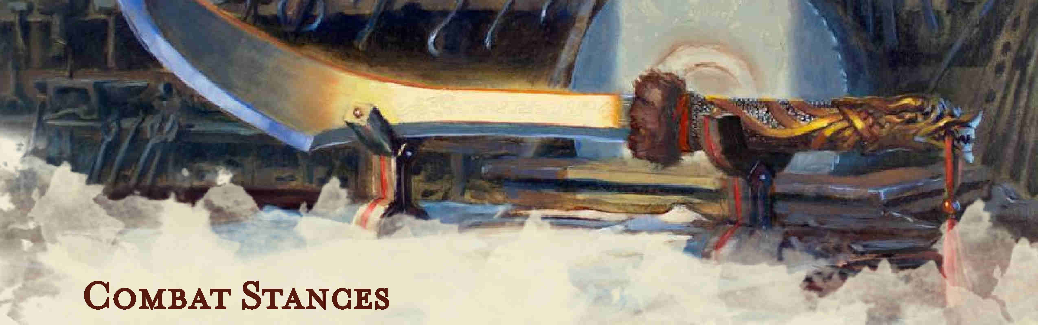

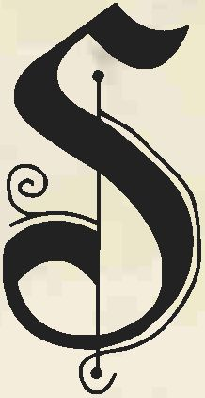

tances were originally presented in the Book of Nine Swords for Third Edition, granting certain classes powers that continually boost a warrior’s abilities. Fifth Edition uses some of this concept in Fighting Styles, available to most martial classes, and this document replaces those features with the following:

Combat Stance

*Replaces Fighting Style*

You adopt a particular style of fighting with the flexibility to shift your stance, flowing seamlessly between offense and defense. Each time you gain this feature, you learn two stances of your choice from the below list. After this, each time you gain Extra Attack, or an improvement to Extra Attack, you learn one additional stance of your choice.

When you gain a level, you can replace one stance you know with another one, if you meet its requirements.

You can enter or change stance when you roll initiative, or as a bonus action on your turn, choosing from your stances known. You can maintain only one stance at a time, and you lose any stance bonus while incapacitated.

Hybrid Stance

*Replaces Additional Fighting Style*

At 10th level, you can enter and maintain two stances at the same time. In addition, you learn one stance of your choice.

Feat: Fighting Initiate

*Prerequisite: Proficiency with a martial weapon*

Your martial training has helped you develop a particular style of fighting. As a result, you learn one Basic Stance of your choice from the fighter class. When you reach a level that grants the Ability Score Improvement feature, you can replace this feat’s stance with another Basic Stance.

Basic Stances

The stances listed below have no prerequisites.

Archery (Soaring Raptor)

*Fighter or Ranger Only*

You gain a +2 bonus to attack rolls with ranged weapons.

Blind-Fighting (Setting Sun)

Being unable to see a creature doesn’t impose disadvantage on your attack rolls against it or grant advantage on its attack rolls against you, provided the creature isn’t hidden from you.

Bulwark (Stonefoot Stance)

When you end your turn without using more than 5 feet of movement, you gain temporary hit points equal to twice your proficiency bonus and have advantage on Strength checks and saving throws. These effects, including any remaining temporary hit points, end at the beginning of your next turn.

Defense (Iron Heart)

You gain a +1 bonus to AC.

Devoted Spirit

*Paladin Only*

You inspire vigor, drive and toughness in your allies. Once per turn when you hit a hostile creature with a melee attack, a creature you choose within 30 feet of you gains temporary hit points equal to your Charisma modifier.

Druidic Warrior

*Ranger Only*

You learn two cantrips from the druid spell list, which you can cast only while in this stance. They count as ranger spells for you, and Wisdom is your spellcasting ability for them. Whenever you gain a ranger level, you can replace one of these cantrips with another cantrip from the druid spell list.

Double Striking (Thicket of Blades)

When you engage in two-weapon fighting, you can add your ability modifier to the damage of the second attack.

Dueling (Desert Wind)

When you are wielding a melee weapon that does not have the heavy property and no other weapons, you gain a +2 bonus to damage rolls with it.

Great Weapon Fighting (Stone Dragon)

*Fighter or Paladin Only*

When you roll a 1 or 2 on a damage die for an attack you make with a melee weapon that you are wielding with two hands, you can reroll the die and must use the new roll, even if the new roll is a 1 or a 2. The weapon must have the two­handed or versatile property for you to gain this benefit.

Protection (Phalanx of Steel)

When a creature you can see attacks a target other than you that is within 5 feet of you, you can use your reaction to impose disadvantage on all of that creature’s attack rolls against that target this round. You must be wielding a shield to grant this benefit.

Skirmishing (Zephyr Dance)

Your movement increases by 5 feet. The first 5 feet of movement you use each turn does not provoke opportunity attacks.

Specialized Technique

*Fighter Only*

You gain the Superior Technique feature (pg. 12) instead of a stance, if you are using both Combat Stances and Maneuvers Expanded. You can choose this feature more than once, gaining the benefits as listed under Superior Technique.

Thrown-Weapon Fighting (Rabid Wolf)

*Fighter or Ranger Only*

When you hit with a ranged attack using a thrown weapon, you add ld4 to the weapon damage roll

Unarmed Fighting (Tiger Claw)

Your unarmed strikes deal bludgeoning damage equal to ld6 + your Strength modifier. If you strike with two free hands, the d6 becomes a d&

At the start of your turn, you can choose to deal bludgeoning damage equal to your Strength modifier to one creature you are grappling.

Bastion

*Prerequisite: Extra Attack 2, Bulwark*

When you gain temporary hit points from the Bulwark stance, you also gain a damage threshold of 10 against nonmagical bludgeoning, piercing, and slashing damage (damage you take that is equal or less than your damage threshold is reduced to 0) until the start of your next turn.

Diamond Mind

*Prerequisite: Extra Attack, Blind-Fighting*

While you are Blind-Fighting, you can use your reaction to add your proficiency bonus to any Wisdom saving throw you make that does not already use your proficiency bonus.

Elder Mountain

*Prerequisite: Extra Attack 2, Defense*

While in the Defense stance, you gain an additional +1 bonus to your AC.

Enfilade

*Prerequisite: Extra Attack 2, Vanguard*

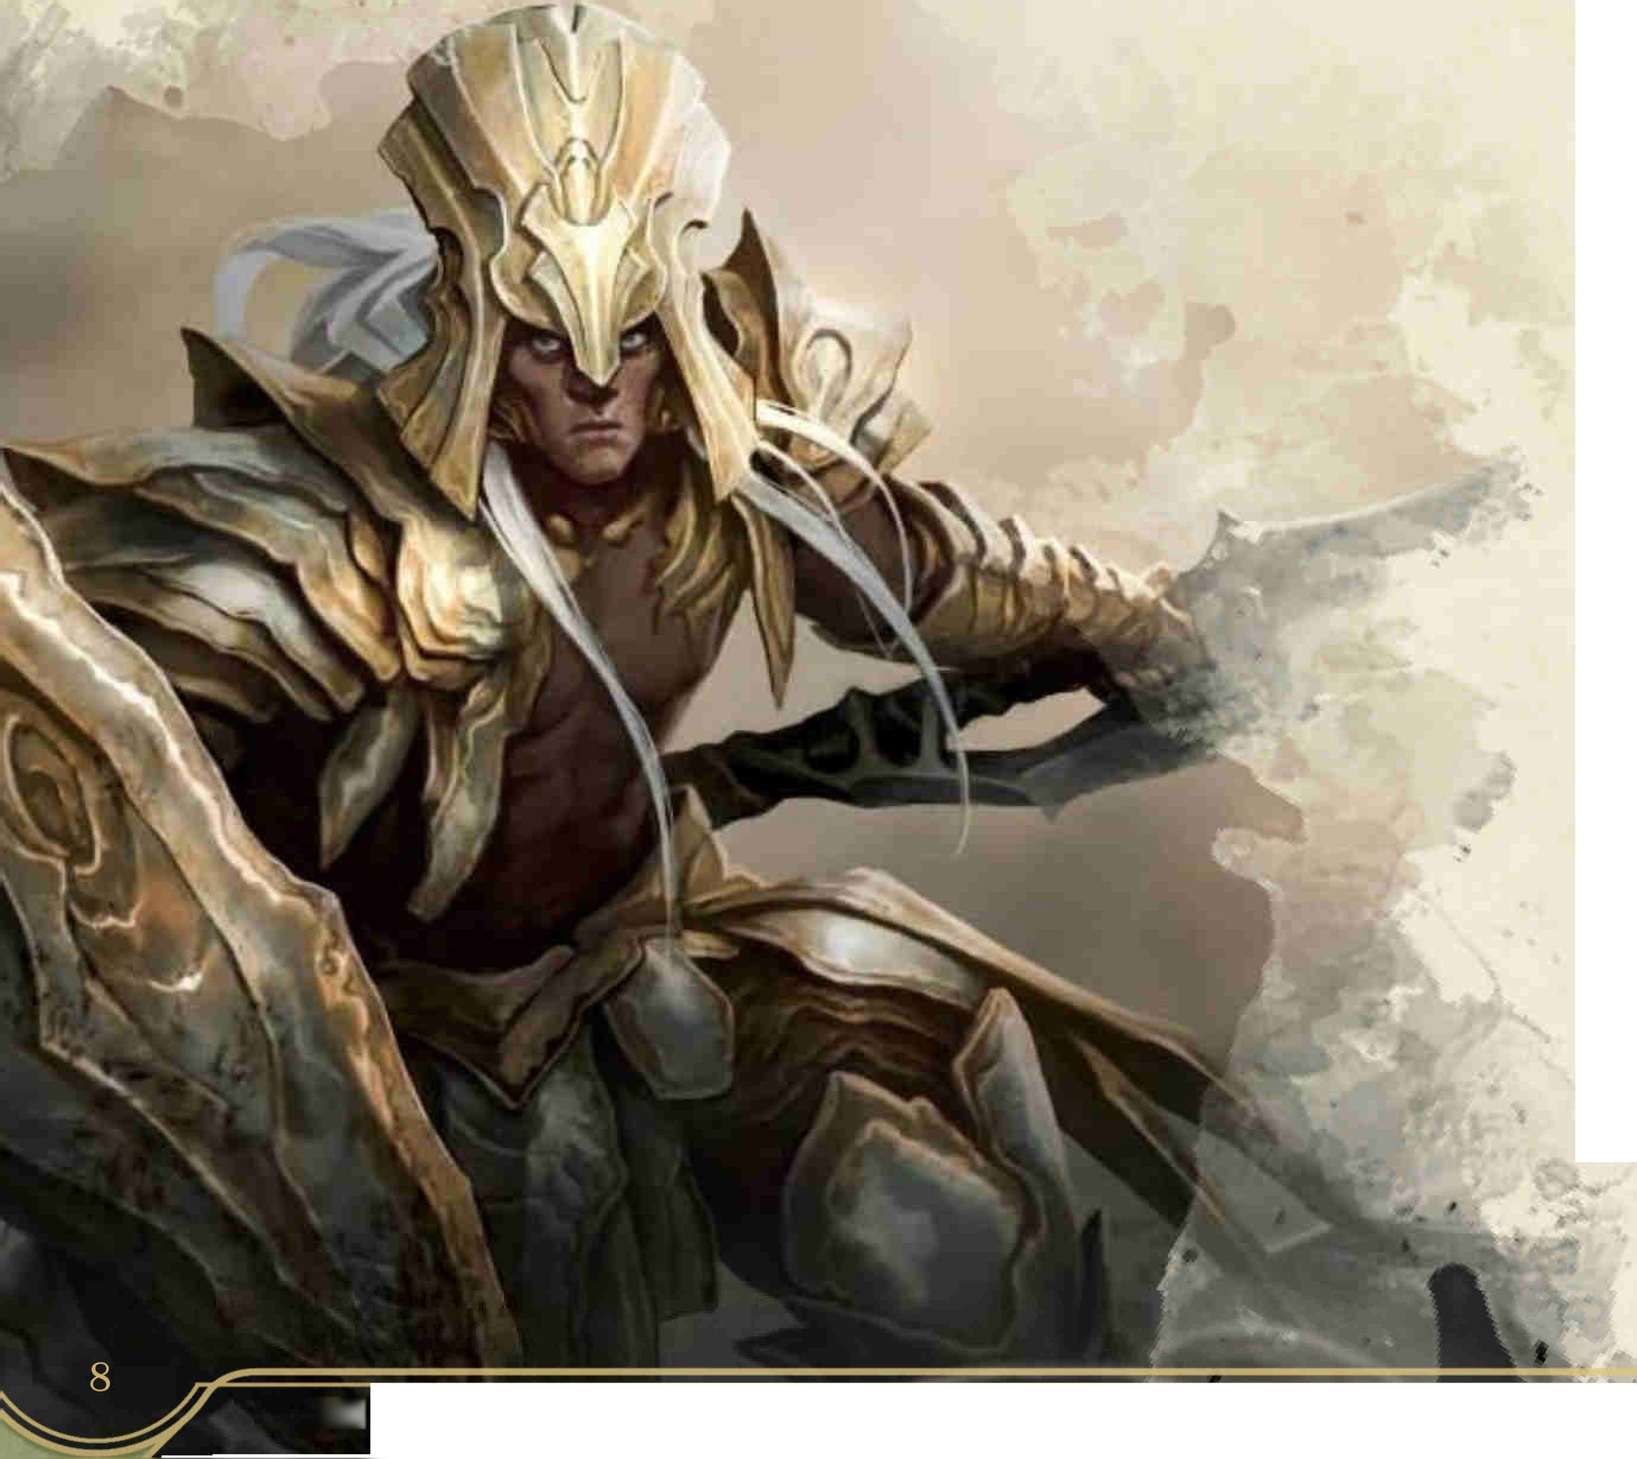

While in the Vanguard stance, if you attack a creature that has not made an attack roll since the beginning of its last turn, your attack roll is made with advantage.

Vanguard (White Raven)

Fencing

*Fighter or Paladin Only*

When you hit a creature with a melee attack, the next attack roll against that creature made by someone other than you has advantage. You must remain within 5 feet of the creature to grant this benefit.

Advanced Stances

To learn or use one of these stances, you must meet the prerequisites listed. An advanced stance improves a basic stance, granting both its benefits and that of the basic stance that it references.

*Prerequisite: Extra Attack 2, Dueling*

While Dueling, if you make a weapon attack with advantage and both rolls would hit the target, roll your damage dice twice and take the better result.

Interception

*Prerequisite: Extra Attack, Protection*

While in the Protection stance and wielding a shield, you can use your reaction to give a creature within 5 feet of you advantage on a Dexterity saving throw. If you are also forced to make a saving throw by the same effect or spell, you gain advantage on your roll.

Pugilism

*Prerequisite: Extra Attack 2, Unarmed Fighting*

When you are Unarmed Fighting and make an unarmed strike with one hand, you can make an unarmed strike or grapple check as a bonus action.

Reprisal

*Prerequisite: Extra Attack, Skirmishing*

If a creature hits you with a melee weapon while you are in Skirmishing stance, you can use your reaction to make a melee attack against it with a weapon that doesn’t have the heavy property. If you hit, do not add your ability modifier to the damage roll

Swarming

*Prerequisite: Extra Attack, Double Striking*

While in the Double Striking stance, you can make the additional attack of two-weapon fighting as part of your Attack action instead of as a bonus action. If you do so, you can’t use your bonus action to make any attack on that turn.

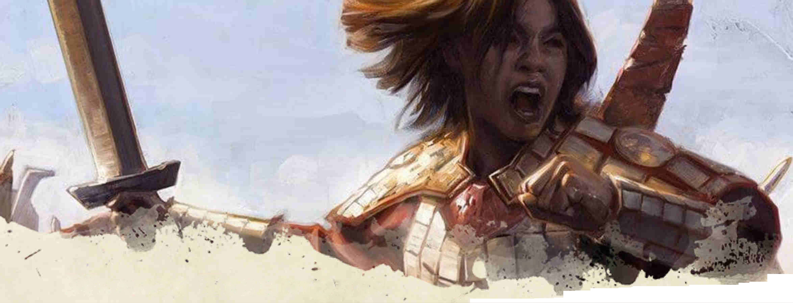

9

Weapon Techniques

/Then a class or feature grants you general

nl I Pr°ficiency with martial weapons, or you choose

I the Pact of the Blade or Path of the Kensei, you

^0 J* can choose to learn a technique that takes advantage of the properties of a weapon or family of weapons, as given on the Weapon Techniques table below. Afterward, you learn one additional weapon technique of your choice each time you gain an Ability Score Improvement.

At your DM's discretion, you can learn a new technique by spending a number of downtime days equal to 10 minus your Intelligence modifier training with an appropriate expert.

X • > V ? ’ X ’ *

• * * , • •

When a technique requires a saving throw, the DC is 8 + your weapon attack bonus. A technique can only be used while wielding a weapon in its list, and when a technique allows you to make an attack, you must do so with a weapon in its list, unless otherwise noted. When a technique deals damage to a creature, you can add any appropriate magical bonus from your weapon to the damage roll.

When a technique is used as a special melee attack, it must replace the attack granted by the Attack action. If you have multiple attacks as part of the Attack action, the technique replaces one of them.

|  |  |
| --- | --- |
|  | |
| Weapon Techniques Reference Table | |
| **Feature** | **Weapons** |
| Abwenden | Longsword, Rapier, Saber, Scimitar, Shortsword |
| Bleeder | Glaive, Hand Axe, Saber, Shortbow, Sickle, War Whip, Whip |
| Bracing | Halberd, Lance, Pike, Spear, Trident, War Whip |
| Cleave | Any Two-handed or Versatile Slashing |
| Close Quarters | Any Improvised, *Cestus,* Dagger, Hand Axe, Shortsword |
| Crippling Cut | Battleaxe, Greetaxe, Longsword, Saber, Scimitar |
| Crushing Blow | Flail, Light Hammer, Mace, Maul, Warhammer |
| Entangle | Net, War Whip, Whip |
| Finisher | *Cestus,* Club, Dagger, Sickle |
| Flexible Flurry | Any Versatile |
| Grazing Clout | *Cestus,* Club, Greatclub, Light Hammer, Mace, Sling |
| Lunge | Halberd, Lance, Pike, Quarterstaff, Rapier, Spear, Trident |
| Paired Weapon | Dagger, Sickle, *Swordbreaker* |
| Piercing Strike | Longsword, Morning-star, War Pick |
| Pinning Shot | Any Bow, Dagger, Dart, Hand axe, Javelin, Heavy or Light Crossbow |
| Ricochet | Any Bow,Hand Axe, Heavy or Light Crossbow, Javelin |
| Shattering Clobber | Any Improvised, Club, Greatclub, Quarterstaff |
| Shield Bash | None (shield) |
| Whirling Rebuff | Greataxe, Halberd, Quarterstaff, Spear, Trident, War Whip |
| Whistling Shot | Any Bow, Any Crossbow, Sling |
|  | |

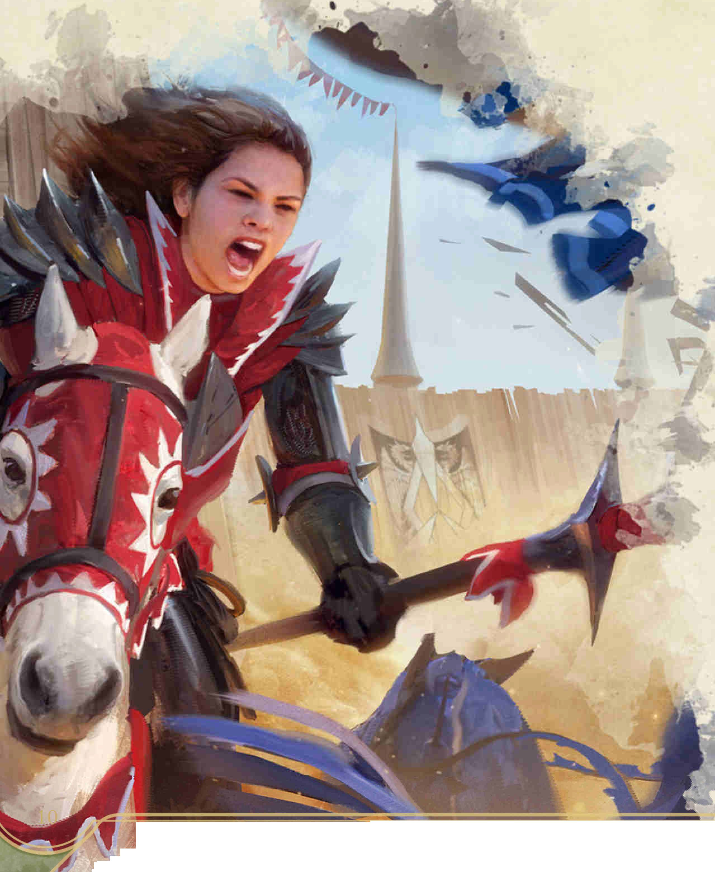

Weapon Techniques

Abwenden

*Longsword, Rapier, Saber, Scimitar, Shortsword*

A fencing parry, warding off a blow using your own blade. When a creature attacks you with a melee weapon and you are not wielding any other weapon or a shield, you can use your reaction to make an attack roll. If the result equals or exceeds the triggering attack roll, the attack misses, unless it is a critical hit. You must choose to use this ability before the attack is rolled

Bleeder

*Glaive, Hand Axe, Saber, Shortbow, Sickle, War Whip, Whip*

When an attack roll with this weapon exceeds the target’s AC by 5 or more, or on a critical hit, the weapon inflicts a bleeding wound A bleeding creature takes 3 slashing damage at the beginning of each of its turns, ending when it receives magical healing or a creature uses an action to make a DC 10 Wisdom (Medicine) check to stop the flow of blood

A creature can have only one bleeding wound at a time.

Bracing

*Halberd, Lance, Pike, Spear, Trident, War Whip*

You can use an action to set a spear or swing a heavy whip to deny entry into the area you threaten. Until the beginning of your next turn, if a creature moves at least 10 feet and enters the reach of your weapon, you can use your reaction to make an opportunity attack against that creature.

If this attack hits, add an additional weapon die to the damage roll, and the creature must make a Strength saving throw. On a failure, it falls prone and if mounted falls from its mount.

Cleave

*Any two-handed or versatile slashing*

Once on your turn in place of a two-handed melee attack, you can choose to strike at up to three creatures within 5 feet of you using a single massive swing. Each targeted creature must be within 5 feet of another targeted creature.

Each target must succeed on a Dexterity saving throw. On a failure, it takes slashing damage equal to ld4 plus your Strength modifier.

Close Quarters

*Any improvised, Cestus, Dagger, Hand Axe,Shortsword*

When you successfully grapple or escape a grapple, you can make one weapon attack as a bonus action. When an opponent fails to escape your grapple, you can make a weapon attack as a reaction.

Crippling Cut

*Battleaxe, Greetaxe, Longsword, Saber, Scimitar*

As a special melee attack, you aim for a vulnerable limb with a precise strike. The target must succeed on a Constitution saving throw or take slashing damage equal to your Strength modifier and have one form of speed (such as walking or flying) reduced by 10 feet (to a minimum of 0). This effect ends when the creature is healed or spends one turn without using any movement.

Crushing Blow

*Flail, Light Hammer, Mace, Maul, Warhammer*

As an action, you can make a single attack roll against a heavily- or naturally-armored enemy within reach. On a hit, you deal your normal weapon damage and the target must succeed on a Constitution saving throw. If it fails, its AC is

reduced by 2 until the armor is repaired or in the case of natural armor, the creature receives magical healing. This ability is ineffective against magical armor and constructs.

A creature’s AC can’t be reduced this way more than once.

Entangle

*Net, War Whip, Whip*

You can make a disarm, grapple, shove, or trip attack while up to 10 feet from your target by using the extra reach of your weapon. Your reach for the grappled condition when using this weapon is 10 feet instead of 5 feet. If you successfully shove a creature using this weapon, you can choose to either push the target five feet away or pull the target five feet closer.

If you grapple at range, you can’t use the weapon to attack or drop the weapon, or the grapple ends. Either combatant can use an action to make an opposed Strength (Athletics) check; the winner can choose to pull the loser up to 5 feet closer. If one creature is larger than the other, it has advantage on this check.

Finisher

*Cestus, Club, Dagger, Sickle*

When you attack a prone or grappled opponent with this weapon, roll an additional damage die.

Attacking with this weapon from a prone position does not incur disadvantage.

Weapon Techniques

Flexible Flurry

*Any versatile*

When you wield a versatile weapon and make a weapon attack using two hands, if you then make a weapon attack using one hand or a grapple check on the same turn, you gain a +1 bonus to your AC until the start of your next turn.

Grazing Clout

*Cestus, Club, Greatclub, Light Hammer, Mace, Sling*

When an attack roll with this weapon misses the target’s AC by 4 or less, the bludgeon still connects, if not as powerfully. The target takes bludgeoning damage equal to the weapon’s damage die.

Lunge

*Halberd, Lance, Pike, Quarterstaff, Rapier, Spear, Trident*

When wielding this weapon, you can use a bonus action to extend yourself in a lunging strike. You gain 5 feet of reach for your next attack.

Paired Weapon

*Dagger, Sickle, Swordbreaker*

While you wield both this weapon and a non-light weapon, you gain a +1 bonus to your AC. Once per turn, you can choose to add ld4 to the damage roll of your other weapon. When you do so, you lose the bonus to AC until the beginning of your next turn, unless you have the Dual Wielder feat.

Piercing Strike

*Longsword, Morning-star, War Pick*

As an action, you can attempt to penetrate an opponent’s heavy or natural armor. The target must succeed on a Dexterity saving throw. On a failure, it takes piercing damage equal to half your normal weapon damage and its AC is reduced by 1 until its armor is repaired, or in the case of natural armor, the creature receives magical healing. This ability is ineffective against magical armor and constructs.

A creature’s AC can't be reduced this way more than twice.

Pinning Shot

*Any Bow, Dagger, Dart, Hand axe, Javelin, Heavy or Light Crossbow*

As an action, you can attempt to pin a Large or smaller creature that is within normal range of your weapon, sticking it to the ground or other terrain. A creature that is immune to the prone condition is unaffected. Otherwise, the target must succeed on a Dexterity saving throw or its speed is reduced to 0 until the end of its next turn. As an action, the creature can pull free and regain its speed.

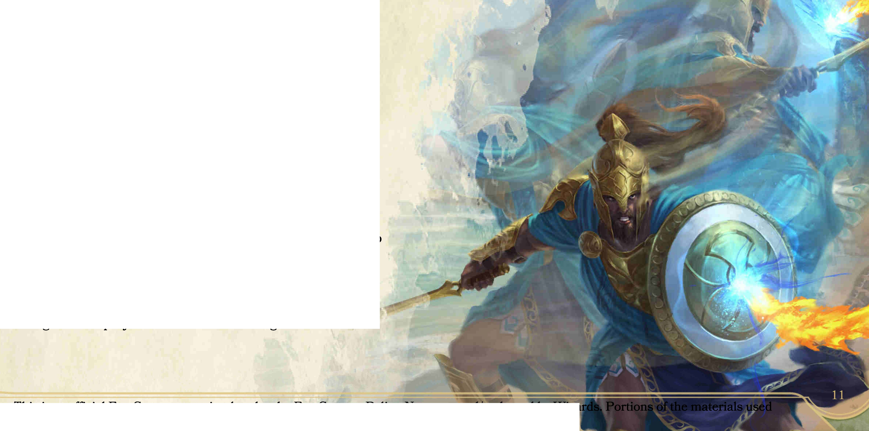

Ricochet

*Any Bow, Hand Axe, Heavy or Light Crossbow, Javelin, Sling*

As an action, you attempt to hit a target that is not visible to you using an object or terrain feature to bounce your shot. Make an attack, reducing the target’s cover from full to partial, or three-quarters to none, provided that the target is within the weapon’s normal range and there is a path large enough for the projectile to travel to the target.

Shattering Clobber

*Any improvised, Club, Greatclub, Quarterstaff*

If you are using an improvised weapon that deals bludgeoning damage or a nonmagical weapon listed above, you can use a weapon attack to strike beyond the limits of your tool, with such force that the weapon breaks. Your weapon is rendered broken and useless, and the target must make a Dexterity saving throw. On a failure, it takes bludgeoning damage equal to a critical hit with your weapon.

Shield Bash

*None (shield)*

As a special melee attack, you drive an opponent off- balance by smashing through their guard with your shield. The target must succeed on a Strength saving throw or it takes bludgeoning damage equal to ld4 + your Strength modifier and your next attack roll against it this turn has advantage.

Whirling Rebuff

*Greataxe, Halberd, Quarterstaff, Spear, Trident, War Whip*

As a special melee attack, you brandish your weapon to drive up to two opponents away. Each creature you target must be within 5 feet from you and one other target. A targeted creature must succeed on a Strength saving throw or be pushed 5 feet in a direction of your choice.

Whistling Shot

*Any Bow, Any Crossbow, Sling*

You fire a projectile near but not at an opponent, diverting its attention to you. As an action, you expend a unit of ammunition to force a creature within 30 feet to make a Wisdom saving throw. On a failure, it has disadvantage on any attack roll that doesn’t target you until the end of its next turn.

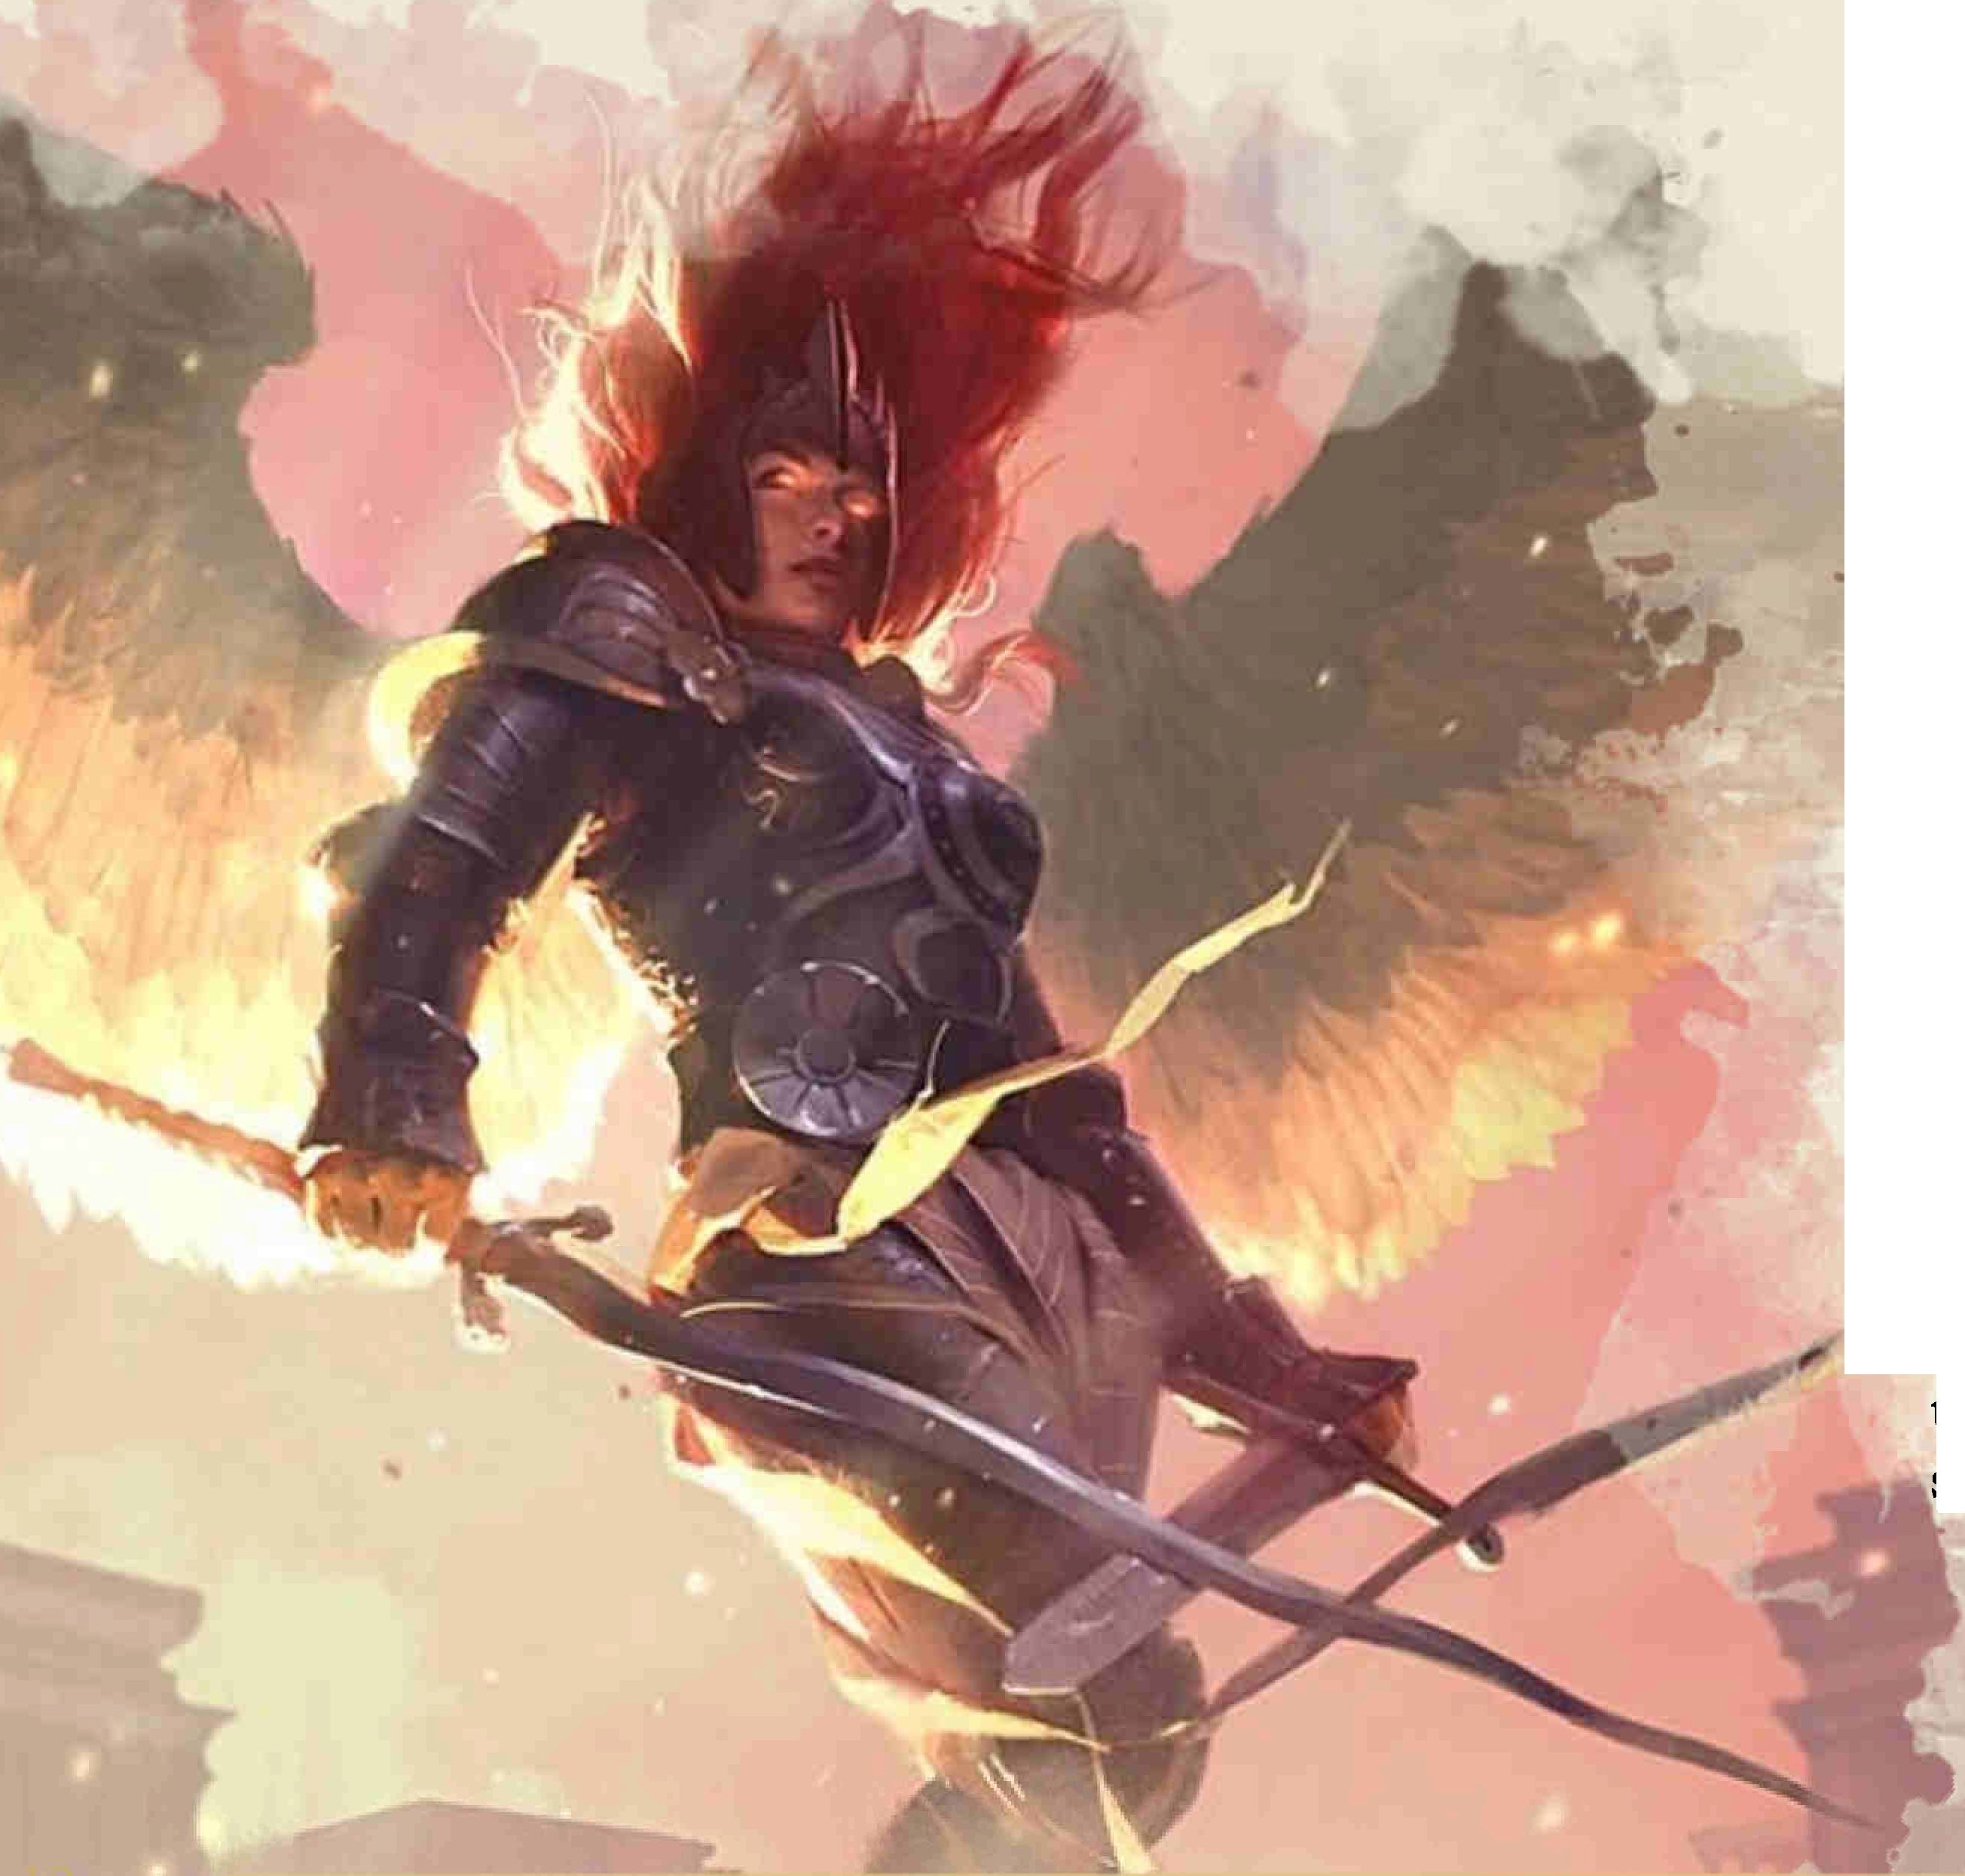

Maneuvers Expanded

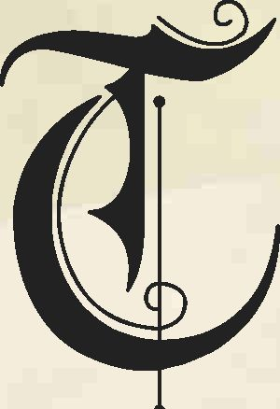

hese combat maneuvers are intended to supplement the ones provided in the PHB for Battlemasters. The Battlemaster Archetype replaces the PHB Combat Superiority feature with the below feature. As an alternative to taking a

Fighting Style or Combat Stance, Superior

Technique grants a measure of Battlemaster prowess to any warrior.

Combat Superiority Revised

*Replaces Combat Superiority*

When you choose this archetype at 3rd level, you learn maneuvers that are fueled by special dice called superiority dice. Choose a specialization - Cut-Throat, Mystic Knight, Savage, or Warlord - which you cannot change later, reflecting the style of your battlefield superiority.

**Maneuvers.** You learn four maneuvers of your choice, which are detailed below, and must be chosen from your specialization or the Combat Maneuvers group. Many maneuvers enhance an attack in some way. You can use only one maneuver per attack.

You can replace one maneuver you know with a different eligible maneuver whenever you finish a long rest.

You learn two additional maneuvers of your choice at 7th, 10th, and 15th level Each time you learn new maneuvers, you can also replace one maneuver you know with a different one, which must be from your specialization or the Combat Maneuvers group.

**Superiority Dice.** You have four superiority dice, which are d8s. A superiority die is expended when you use it. You regain all of your expended superiority dice when you finish a short or long rest. You gain another superiority die at 7th level and one more at 15th level

**Saving Throws.** Some of your maneuvers require your target to make a saving throw to resist the maneuver’s effects. The saving throw DC is calculated as follows:

**Maneuver save DC =** 8 + your proficiency bonus + your Strength or Dexterity modifier (your choice)

Superior Technique

*Replaces Martial Adept*

Choose a specialization - Cut-Throat, Mystic Knight, Savage, or Warlord - if you do not have one already. You learn two Maneuvers from your chosen specialization, following the rules above except as modified below.

You gain one superiority die, which is a d6 (this die is added to any superiority dice you have from another source) and does not change size as you gain levels. If you gain this feature again, you learn one additional maneuver from your specialization and gain one additional d6 maneuver die.

Unless you also have Combat Superiority, you cannot replace maneuvers gained from this feature at the end of a long rest. Instead, when you gain a level, you can replace one maneuver you know with a different maneuver from your specialization.

Combat Maneuvers

An asterisk (*) denotes a modified PHB maneuver.

Breaking the Wall

As a bonus action, you focus briefly to battle beyond the limits of your endurance. You expend one hit die and recover one superiority die, up to your maximum number of superiority dice.

Disarming Attack

*PHB pg. 74*

Feinting Attack

*PHB pg. 74*

Goading Attack

*PHB pg. 74*

Lunging Attack*

When you make a melee weapon attack on your turn, you can expend one superiority die to increase your reach by 5 feet until the end of your turn. If you hit with this attack, add your superiority die to the attack’s damage roll

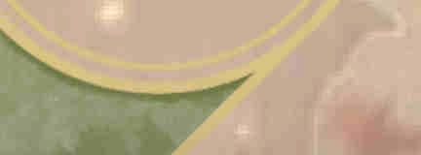

Parry

*PHB pg. 74*

Precision Attack

Dirty Trick

Your underhanded moves surprise your enemies. As an action, you can expend a superiority die to force a creature within 5 feet of you to make a Wisdom saving throw. On a failure, the creature takes bludgeoning or piercing damage equal to your superiority die, and it is blinded until the end of its next turn.

*PHB pg. 74*

Evasive Footwork*

Pushing Attack

*PHB pg. 74*

Reactive Strike

When you move, you can expend one superiority die, rolling the die and adding the result to your AC until the end of your turn. If you take the Dash, Disengage, or Dodge action, the bonus instead lasts until the start of your next turn.

Flash of Steel (QuickToss*)

As a bonus action, you can expend one superiority die and make a ranged attack with a light weapon that has the thrown property, drawing it from an appropriate container. If you hit, add your superiority die to the attack’s damage rolL

As a reaction to a creature moving into the reach of your weapon, you expend a superiority die and make a melee attack against it. On a hit, you deal additional damage equal to your superiority die and the creature loses 10 feet of movement (to a minimum movement of zero)i

Studious Eye (Tactical Ass ess me nt)

*TCEpg.42*

Humanoid Shield

If you are grappling a creature and are attacked by any other creature, you can expend a superiority die to move 5 feet into an unoccupied space without provoking opportunity attacks and pull the grappled creature into your vacated space. Both of you must fit in the space available. The creature becomes the target of the triggering attack instead of you.

Silencing Strike

When you hit a creature with a weapon attack, you can expend a superiority die to inhibit its ability to speak or shout.

Sweeping Attack*

You add your superiority die to the damage roll, and the

When you hit a creature with a melee weapon attack, you can expend one superiority die to attempt to damage another creature with the same attack. Choose another creature within 5 feet of the original target and within your reach. If the original attack roll would hit the second creature, it takes damage equal the number you roll on your superiority die plus your Strength or Dexterity modifier (your choice^ The damage is of the same type dealt by the original attack.

Tripping Attack

*PHB pg. 74*

Cut-Throat Maneuvers

Alternative Medicine

As a bonus action, you expend a superiority die binding the wounds of yourself or another. The target regains hit points equal to your die roll, and can choose to expend a hit die, regaining hit points as if it had done so during a short rest. After a creature benefits from this effect, it cannot do so again until it finishes a short or long rest.

Ambush

*TCEpg.42*

creature must succeed on a Constitution saving throw or be unable to speak clearly beyond 10 feet or cast a spell with a verbal component until the end of your next turn.

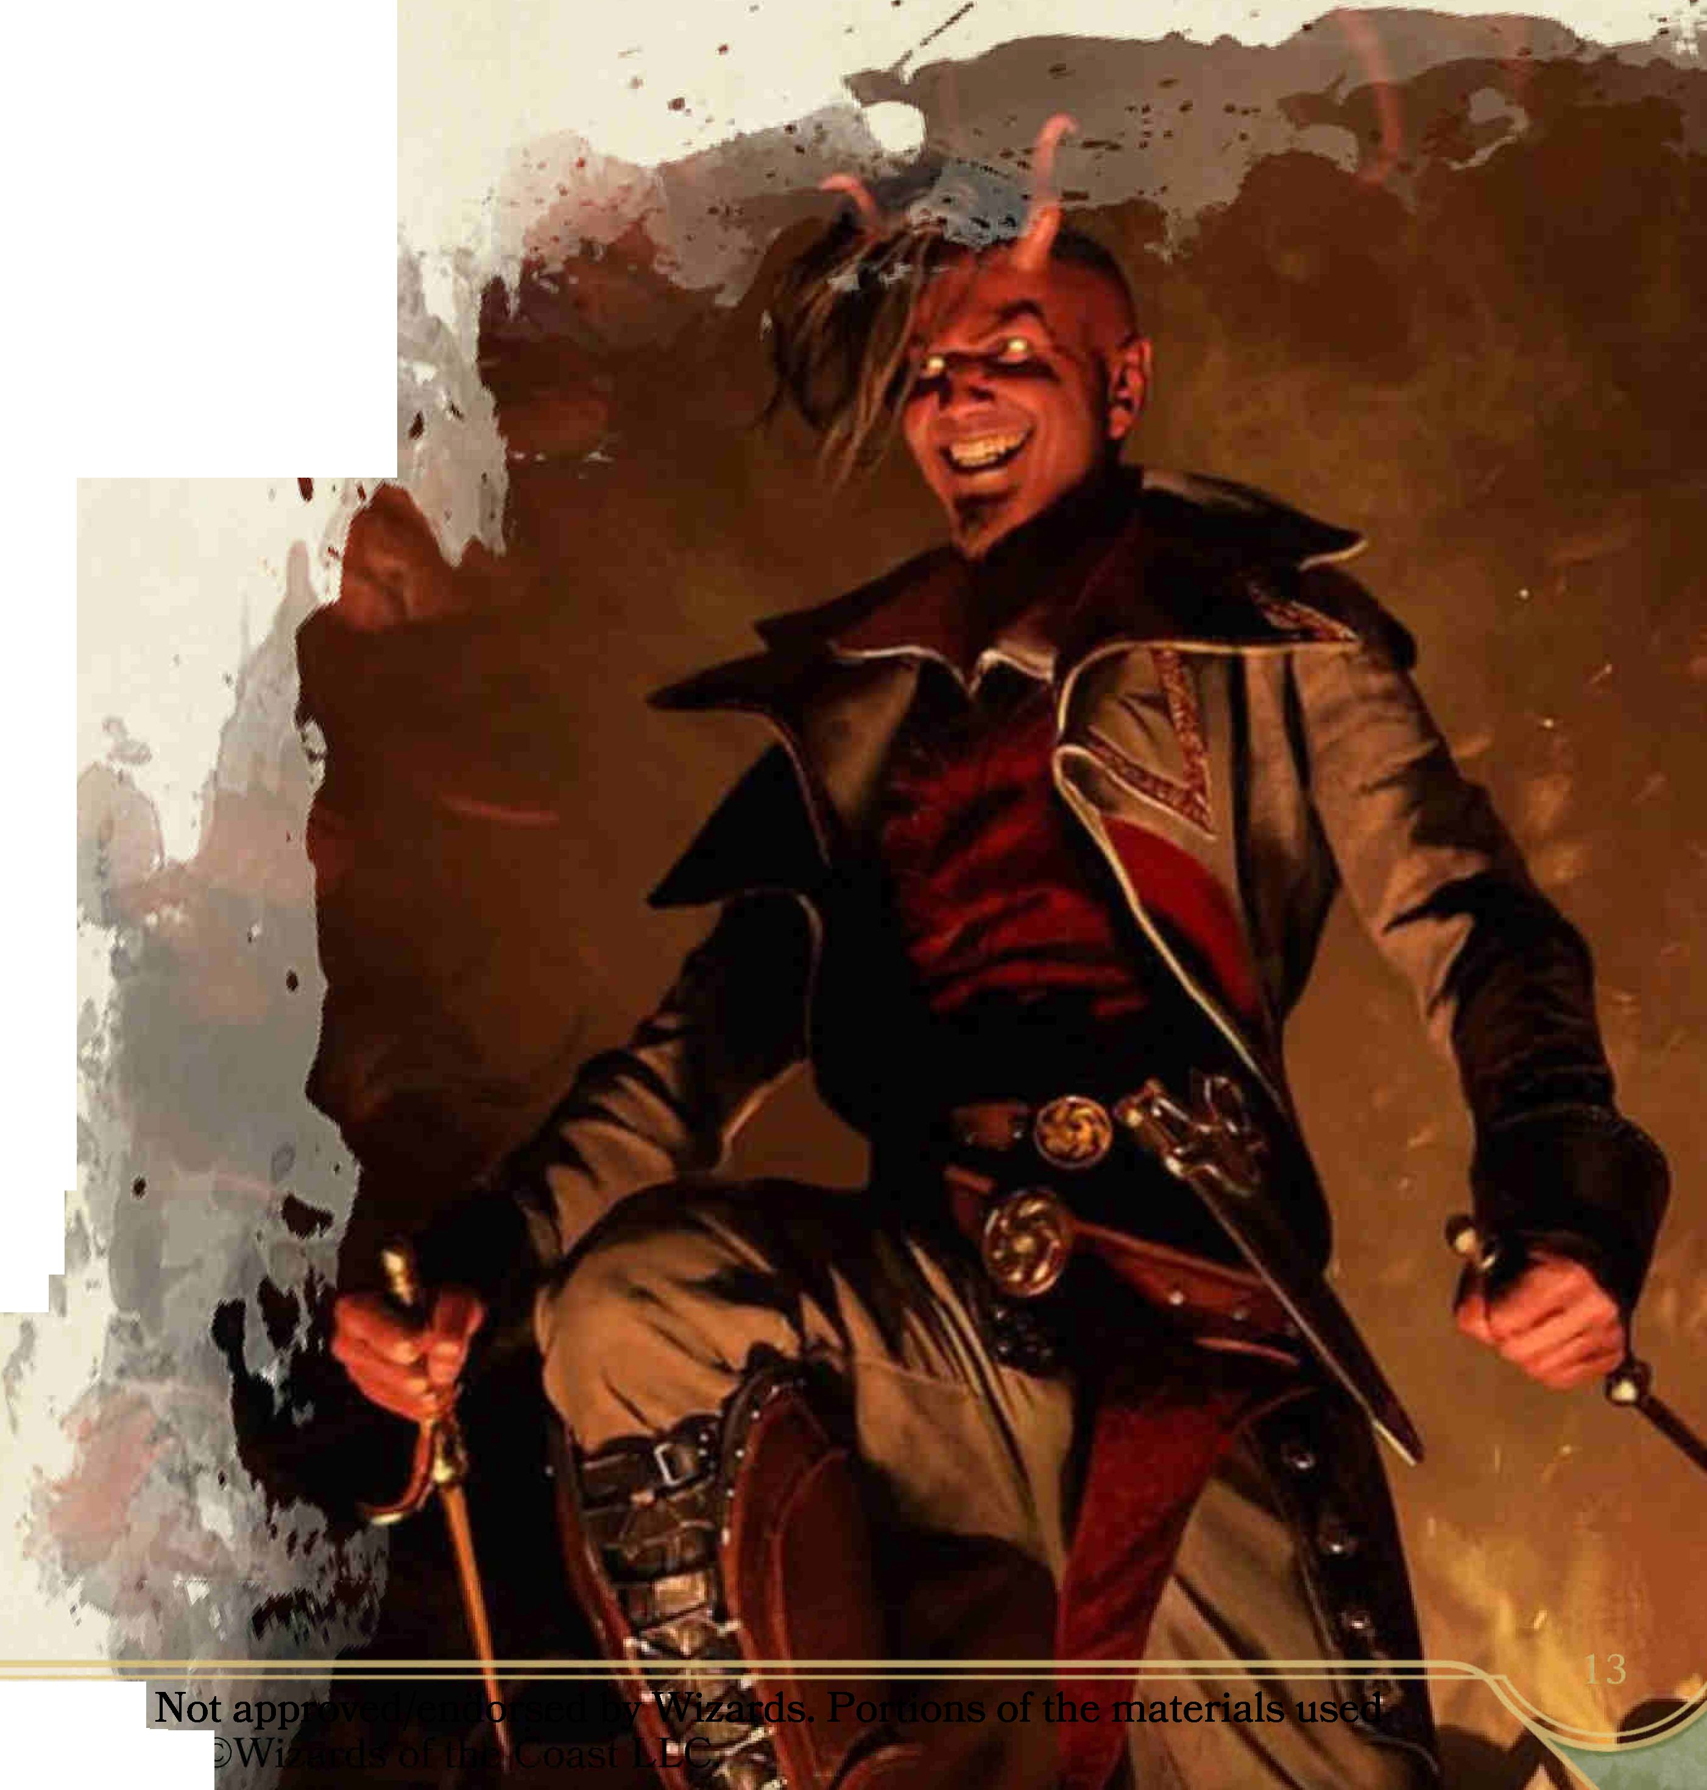

Smash and Grab

Immediately after you hit a creature with a melee weapon attack on your turn, you can expend one superiority die and use a bonus action to attempt to grapple the target (see chapter 9 in the Player’s Handbook). Add your superiority die to your Strength (Athletics) check.

Snipe

As a bonus action, you can expend a superiority die to carefully aim, giving yourself advantage on your next ranged attack. If you hit, add your superiority die to the damage roll

Venomous Strike

As a bonus action, you can expend one superiority die to coat a melee weapon, or up to three pieces of ammunition, with a venom or toxin that you have on your person. The first attack you make with the envenomed weapon deals extra poison damage equal to your superiority die.

Mystic Knight Maneuvers

Arcanist's Eye

When you make a Intelligence (Religion) or Intelligence (Arcana) check, you can expend a superiority die and add the die roll to the result.

Airborne Spellstrike

As a bonus action, you can expend a superiority die and lift yourself off the ground briefly. You gain a flying speed equal to half your walking speed until the end of your turn. If you hit with the next weapon attack you make this turn, add your superiority die to the damage roll If you end your turn in the air, you float safely downward a distance up to your flying speed, then begin to falL

Branding Spellstrike

When you hit a creature with a weapon attack, you can use a bonus action to expend a superiority die and release divine energy. Your attack deals your superiority die in extra radiant damage to the target, which becomes visible if it’s invisible, and the target sheds dim light in a 5-foot radius until the end of your next turn.

Chilling Spellstrike

When you hit a creature with a weapon attack, you can use a bonus action to expend a superiority die and release painful frost in a 15 foot cone that emanates from you and includes the target. Any creature in the area must make a Dexterity saving throw or take cold damage equal to your superiority die.

Enfeebling Spellstrike

When you hit a creature with a weapon attack, you can use a bonus action to expend two superiority dice of the same size and release negative energy. The attack deals extra necrotic damage equal to your superiority die to the target, and the target must succeed on a Constitution saving throw or it deals only half damage with weapon attacks that use Strength until the end of its next turn.

Ensnaring Spellstrike

When you hit a creature with a weapon attack, you can use a bonus action and expend a superiority die to summon grasping vines, restricting its movement with vicious thorns. Until the end of its next turn, for each 5 feet the target willingly moves it must make a Dexterity saving throw. On a failure, it takes your superiority die in piercing damage. On a success, it breaks free and this effect ends.

Flickering Defense

You can use a bonus action to partially blink through the ethereal plane, expending a superiority die. Until the start of your next turn, when you are hit by an attack, roll your superiority die. On a 1 or 2, you take damage as usual. On any other result, you gain resistance to the triggering damage.

Ignited Spellstrike

When you hit a creature with a weapon attack, you can use a bonus action to expend two superiority dice of the same die size. The target takes fire damage equal to your superiority die and must make a Dexterity saving throw or be set aflame for one minute. At the start of each of its turns, the creature takes fire damage equal to your your superiority die, ending when it uses an action to put out the flame or is otherwise doused

Shocking Spellstrike

When you hit a creature with a melee weapon attack, you can use a bonus action to expend a superiority die and release a burst of static. You deal extra lightning damage equal to your superiority die and the target is unable to take reactions until the end of its next turn.

Thunderous Spellstrike

You can use a bonus action to charge a melee weapon with sonic energy, expending two superiority dice with the same die size. Each time you attack a creature with this weapon on this turn, all creatures in a 10 foot cube originating from you and including the creature must make a Strength saving throw. On a failure, a creature takes thunder damage equal to your superiority die and is pushed 5 feet away from you. On a success, a creature takes no damage and is not pushed

Savage Maneuvers

Crippling Strike

When you hit a creature with a melee weapon attack, you can expend one superiority die and cause a lingering injury. The creature must succeed on a Constitution saving throw or be maimed in one of the following ways (your choice):

* If the creature attacks with a weapon held in two hands or while wielding a shield, it takes a penalty equal to your superiority die.
* One form of the creature’s speed (such as walking or flying) is reduced by an amount equal to twice your superiority die.

At the end of each of its turns, a maimed creature can repeat the saving throw, ending the effect on a success.

Enraged Strike

As a bonus action, you can expend a superiority die and harness pain to fuel your next attack. If you hit with an attack before the end of your next turn, you deal additional damage equal to half the total damage you’ve taken since initiating this maneuver, plus your superiority die, and the effect ends.

Feral Sense

When you make a Wisdom (Survival) check, or a Wisdom (Perception) check that relies on hearing or smell, you can expend a superiority die and add the die roll to the result.

Hemorrhagic Strike

When you hit a creature with a melee weapon attack, you can expend one superiority die and cause it to start bleeding for one minute. At the start of each of its turns, the creature takes your superiority die in slashing damage. At the end of each of its turns, the creature can make a Constitution saving throw, ending this condition on a success. The target or another creature can also stop the bleeding with an action, either by making a DC 10 Wisdom (Medicine) check or expending a use of a Healer’s Kit.

Heroic Might

You can expend a superiority die to perform a momentary feat of strength beyond that of ordinary men. Add your superiority die to your Strength for the purposes of determining how far or high you can jump, or how much weight you can lift, carry, push, or throw.

This temporary Strength lasts until you finish the feat (such as leaping a crevasse), or one minute, whichever is shorter.

Juggernaut Charge

When you take the Dash action, you can expend a superiority die and charge in a straight line through any number of creatures your size or smaller, as long as you have movement to do so. Each time you do so, the creature can choose to move 5 feet into an empty space as a reaction, if it can, or else it takes your superiority die plus your Strength modifier in bludgeoning damage. If you would end your turn in another creature’s space, you are instead shunted to the nearest empty space, provoking opportunity attacks from any hostile creature that can reach you.

Menacing Attack

*PHBpg. 74*

Packleader's Howl

Roaring in rage, you inspire your allies to greater ferocity. As a bonus action, choose up to three other creatures within 30 feet who can hear you and expend a superiority die. If an affected creature hits with its next attack roll before the start of your next turn, add your superiority die to its damage.

Savage Constitution

If you are under the effects of the charmed, frightened, or poisoned condition on your turn, or an effect that allows you to make a saving throw at the end of each of your turns, you can use your bonus action to expend a superiority die and immediately make a saving throw against the original saving throw DC, ending the condition on a success.

Shake Off

When you make a an ability check to defend against a grapple, or a saving throw against an effect that subjects you to the grappled, prone, restrained, or stunned condition, you can expend one superiority die and add the die roll to your check or saving throw.

Sundering Strike

When you hit a creature with a melee weapon attack, you can use a bonus action to expend one superiority die and damage natural, medium, or heavy armor. Add your superiority die to the damage and the creature must make a Constitution saving throw or its AC is reduced by by 1 until the damage can be repaired, which can be done in ten minutes with armorer’s tools. In the case of natural armor, the AC reduction ends when the creature receives magical healing equal to your superiority die size.

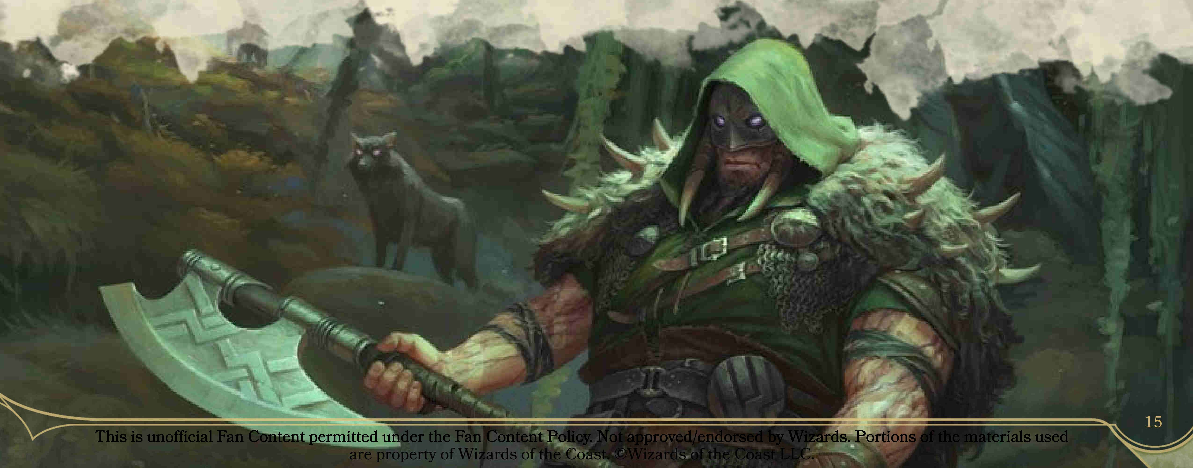

Warlord Maneuvers

Battle Relief (Bait and Switch*)

As part of your movement into the space of a willing creature within 5 feet, you can move the creature into the space you previously occupied and roll a superiority die. Until the start of your next turn, the ally gains a bonus to AC equal to the number rolled You must both fit in the space available, and neither you nor the target provoke opportunity attacks for this movement.

Brace

*TCEpg. 42*

Commander's Strike*

When you take the Attack action on your turn, you can forgo one of your attacks to direct one of your companions to strike. When you do so, choose a friendly creature who can see or hear you and expend one superiority die. That creature can immediately use its reaction to make one weapon attack, adding your superiority die to the attack’s damage roll.

Coordination

On your turn, you can use your action to issue coordinating orders to your allies. Expend a superiority die. Roll the die and distribute a bonus to initiative to any number of other creatures that can hear you, up to a total bonus equal to the die roll plus your Charisma modifier.

Distracting Strike

*PHBpg. 74*

Inciting Strike

When you hit a creature with a melee weapon attack, you can expend one superiority die and create an opening for your allies. Until the start of your next turn, attack rolls against the creature are considered one higher for the purposes of determining whether or not the result is a critical.

Inspiring Cry

When a creature who can hear you makes an attack, you can use a reaction to energize the assault. Expend a superiority die and add the result to the attack roll. If the attack would hit without the bonus, add the die instead to the damage roll

Maneuvering Attack

*PHBpg. 74*

Rally

*PHB pg. 74*

Riposte

*PHBpg. 74*

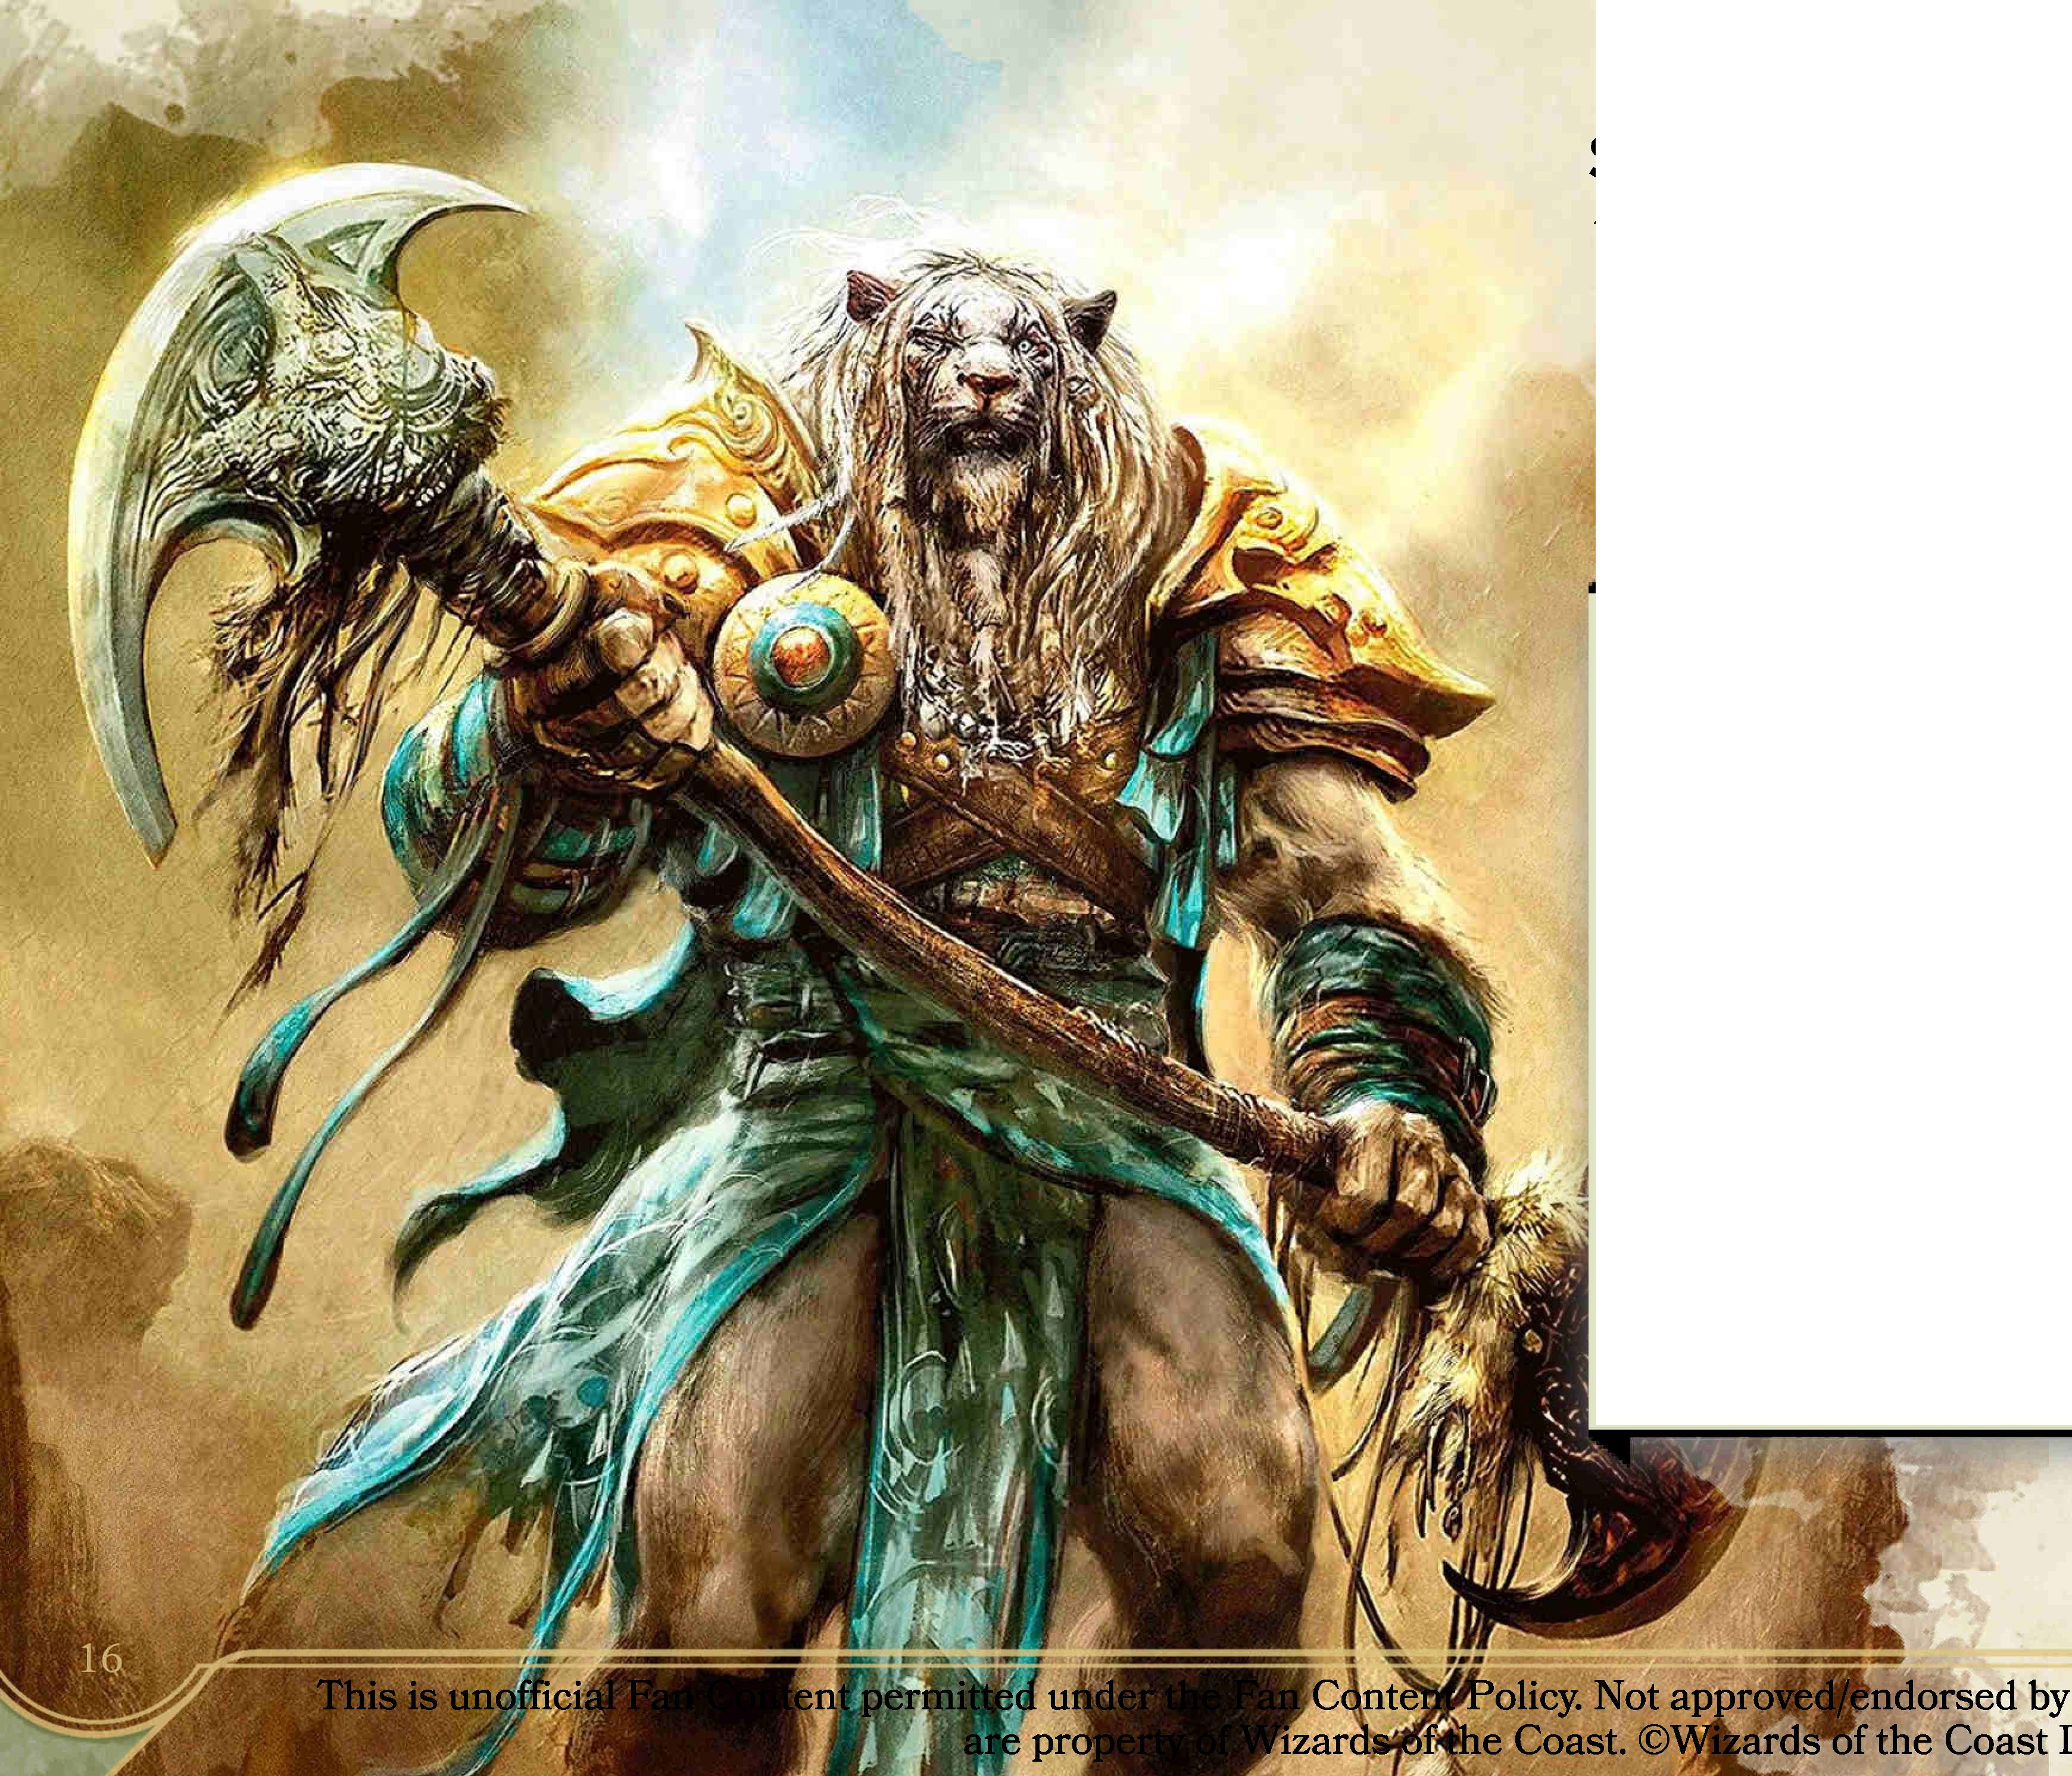

*Martial Prowess v 1.9* by u/RSquared

**Art Credits:**

*Venerable Knight,* Colin Boyer *Radha, Heart of Keld,* Chris Rahn *Hero’s Blade,* Aaron Miller *Puresteel Paladin,* Jason Chan *Chief of the Edge,* David Palumbo *Joust,* Bram Seis

*Whirlwind Denial,* Lie Setiawan *Aurelia the Warleader,* Slawomir Maniak *Tibalt, Rakish Instigator,* Chase Stone *Carruk, Cursed Huntsman,* Dmitry Burmak *Ajani Coldmane,* Aleksi Briclot © Wizards of the Coast